Week Two: American Foreign Policy Project
American Foreign Relations with Russia
Overview
After students have attended and taken notes from the guest scholar’s Russo-American foreign policy lecture, they will work in groups to produce a policy briefing that demonstrates their understandings. Taking on the role of foreign policy advisors to the president, student groups will research, write, and produce a briefing that will clearly identify their assigned foreign policy issue, connect it to prior foreign policy precedence, propose an action or solution, and evaluate the potential costs and benefits of their plan. Students will present their four to five minute brief on one of the Cuban missile crisis.

Objectives
Students will be able to:
- Identify and explain America’s past foreign policy relations with Russia
- Examine primary source documents to ascertain relevant Russo-American foreign policy lessons
- Apply American foreign policy lecture notes to a modern problem in Russo-American relations
- Propose an action or suggested diplomatic idea that will address a current issue in Russo-American foreign policy
- Provide historical precedence for their suggested action or idea
- Present their findings in a concise presentation that clearly defines a problem and how their solution contributes positively and negatively to on-going Russo-American relations

Essential Question
Should President Kennedy have risked thermonuclear war to remove Soviet missiles from Cuba?

Number of Class Periods
One 90 minute period
- 35 Minutes research
- 35 Minutes writing/editing
- 20 Minutes presenting

Grade Level
11th Grade

Common Core Standards
- CCSS.ELA-LITERACY.RH.11-12.1
Cite specific textual evidence to support analysis of primary and secondary sources, connecting insights gained from specific details to an understanding of the text as a whole.
- CCSS.ELA-LITERACY.RH.11-12.2
Determine the central ideas or information of a primary or secondary source; provide an accurate summary that makes clear the relationships among the key details and ideas.
- CCSS.ELA-LITERACY.RH.11-12.3
Evaluate various explanations for actions or events and determine which explanation best accords with textual evidence, acknowledging where the text leaves matters uncertain.
- CCSS.ELA-LITERACY.RH.11-12.7
Integrate and evaluate multiple sources of information presented in diverse formats and media (e.g., visually, quantitatively, as well as in words) in order to address a question or solve a problem.

Materials
- Student lecture notes from Week One
- Primary Source Documents
  - #1: Memorandum for Discussion During Cuban Missile Crisis, October 17, 1962
  - #2: Notes on Meeting with President, October 21, 1962
  - #3: Record of Meeting During the Cuban Missile Crisis, October 19th, 1962
  - #4: Report on Major Consequences of Certain US Courses of Action in Cuba, October 20, 1962
  - #5: Handwritten Summary Note of Meeting, October 22nd, 1962
  - #6: Scenario for Airstrike Against Offensive Missile Bases & Bombers in Cuba, October 25, 1962
- Secondary Sources
  - Lecture One Notes
  - “Kennedy Library Observes Fortieth Anniversary of Missile Crisis,” Prologue, Vol. 34, No. 3
- Graphic Organizer student handout
- How to Conduct a Presidential Briefing student handout
- Optional: Computer access (additional research)

Procedure
- Teacher distributes copies of secondary source, INDIVIDUAL graphic organizer, and primary source texts one and two (half of the students get #1, the other half get #2).
- Students review the documents independently and record their findings on the graphic organizer
- Students are partnered with another student who read the same primary source and they compare notes
- Students are then group with another pair who has read a different document
- Students are given the GROUP graphic organizer and share out their partner research
- Students are given documents #3-6 and must utilize information from at least two of these new sources in their briefing
- Students are given the “How to Conduct a Presidential Briefing” handout
- Groups collaborate to produce one concise written policy brief
- Each student group presents their policy brief to the class and teacher

Steps to Creating a Presidential Briefing

You will have seventy minutes to collaborate in a group to present a short presidential briefing on the Cuban Missile Crisis. Follow the steps below to complete this project using your lecture notes, and the provided primary and secondary sources.

- Review your notes from the Russia lecture (4/18)
- Read and review the secondary source provided for you
- Read and review the primary source document provided for you
- Complete the graphic organizer labeled “INDIVIDUAL”
- Compare notes and consolidate arguments with partner
- Bring your partnership’s findings to the rest of the group
- As a group, complete the graphic organizer labeled “GROUP”
- Get “How to Conduct a Presidential Briefing” from the teach and outline the major points and evidence of your briefing
- Draft your three to five minute briefing script
- Select a group spokesperson to present the briefing
- Conduct at least one rehearsal and provide critical feedback

Presidential Foreign Policy Briefing
INDIVIDUAL GRAPHIC ORGANIZER

Assigned Russo-American Foreign Policy Issue:

Important Points
- What are the 5Ws of your assigned situation from the primary source (and additional research)?

Relevant Points:
- Using your lecture notes, what events/ideas from Russo-American relations is relevant to the situation?

Suggested Action/Idea:
- What possible solutions could you suggest?

Possible Benefits of Suggestions:
- What benefits could America gain in resolving this situation (political, economic, geographic, etc)

Possible Costs of Suggestions:
- What negative outcomes could impact America in resolving this situation (political, economic, geographic, etc)

Presidential Foreign Policy Briefing
GROUP GRAPHIC ORGANIZER

Assigned Russo-American Foreign Policy Issue:

Background on the Assigned Foreign Policy Issue:

Historical Context:

Historical Precedence:

Suggested Action/Idea:

Possible Benefits of Suggestion:

Possible Costs of Suggestion:
How to Conduct a Presidential Briefing

The President of the United States is a very busy man. As his foreign policy advisory team you must get the president up to speed on the situation presented to you. Your briefing message must be clear, logically outlined and argued, concise, and be four to five minutes in length.

Your briefing must include:
- An explanation of the foreign policy issue at hand
  - In clear terms explain the background of the situation assigned to your group
- Background information on Russo-American foreign policy history relevant to this situation
- A proposed action or decision for the president to consider
  - Your proposal must include a historical precedence that either
    - demonstrates a need to act
    - demonstrates past failures of acting
- A cost-benefit analysis of enacting your proposal
  - A summation of possible negative and positive outcomes in adopting your resolution

Framework for Presentation

- Paragraph One
  - Introduce yourself to the president
  - thank him for the opportunity to brief him
  - explain your thesis argument
    - What’s the problem? What’s your solution? Why?

- Paragraph Two
  - Explain the situation as you understand it in Cuba as of October 25, 1962
  - 5 W’s and what’s at stake

- Paragraph Three
  - Explain to the president the relevant Cold War history that has preceded this crisis
    - A summary of Soviet relations and how the Cold War has led to this crisis

- Paragraph Four
  - Propose a clear action or policy that the president can adopt to resolve the crisis
    - What is your recommendation? Why?
    - What are the potential positives and negatives of this plan?
    - Why do the positives outweigh the negatives?

- Paragraph Five
  - Closing, summative statement
    - Restate your recommendation, why it is good advice, and at least one potential benefit
  - Thank the president for his time
  - Ask him if he has any questions
Secondary Source
Introduction
The Cuban Missile Crisis was an intense, two week standoff between the United States and the Soviet Union over the placement of Soviet missiles on the island nation of Cuba in the Summer and Fall of 1962. Cuba, only ninety miles from American soil, was an uncomfortably close location for Soviet nuclear weapons, as from there they could strike any major U.S. city without any warning. Explore the secondary source article below to understand the basic timeline of events before reviewing pertinent primary sources.
This excerpt can be found at http://www.archives.gov/publications/prologue/2002/fall/cuban-missiles.html This article was adapted from The Cuban Missile Crisis: President Kennedy's Address to the Nation, published by NARA in 1988 as part of its "Milestone Documents in the National Archives" series.
----------------------------------------------------------------------------------------------------------------------------------------------
The week of October 7, 1962, saw bad weather in the Caribbean, preventing American U-2 surveillance planes from making more reconnaissance flights over Fidel Castro's Cuba, just ninety miles off the Florida coast.
But Sunday morning, October 14, was cloudless, and the U-2 flight got some good photos— pictures that, over the next few days, were analyzed and reanalyzed. They provided positive proof of what the United States had for months suspected: that the Soviet Union was installing medium-range nuclear weapons in Castro's Cuba, capable of striking major U.S. cities and killing tens of millions of Americans within minutes.
Faced with this dramatic documentation, President John F. Kennedy immediately decided that the missiles would have to be removed and called his most trusted advisers together to serve as an Executive Committee of the National Security Council, or ExComm. Its job was to develop possible responses to the buildup of missiles and the consequences the buildup represented.
Forty years later, what is now known as the "Cuban Missile Crisis," which lasted for several weeks, is remembered as the hottest moment in the Cold War between East and West and a defining moment in Kennedy's presidency.
US forces around the world were placed on alert. Four tactical air squadrons were readied for air strikes over Cuba, with missile sites, airfields, ports, and gun emplacements as their potential targets. More than 100,000 troops were sent to Florida for a possible invasion of Cuba. The navy dispatched 180 vessels into the Caribbean for a planned amphibious exercise involving 40,000 marines. B-52s loaded with nuclear weapons were in the air at all times.
* * *
With the October 14 photographs, the United States had caught the Soviet Union building offensive nuclear missile bases in its backyard, and the two superpowers were now joined in the first direct nuclear confrontation in history.
Throughout 1962, the movement of Soviet personnel and equipment to Cuba had aroused suspicions in the American intelligence community. In response, US ships and planes began photographing every Cuba-bound Soviet vessel, and U-2 spy planes began regular reconnaissance flights over the island.
The first evidence of the arrival in Cuba of surface-to-air missiles, missile-equipped torpedo boats for coastal defense, and large numbers of Soviet military personnel came in photographs taken in late August. But these pictures provided no evidence of offensive ballistic missiles. In September, Kennedy delivered two explicit warnings to Soviet Premier Nikita Khrushchev regarding the buildup of what were being called "defensive" Soviet arms in Cuba.
On September 13, Kennedy wrote: "If at any time the Communist build-up in Cuba were to endanger or interfere with our security in any way . . . or if Cuba should ever . . . become an offensive military base of significant capacity for the Soviet Union, then this country will do whatever must be done to protect its own security and that of its allies."
Despite Kennedy's warnings, the Soviets continued to construct the bases, and the United States continued to monitor their activities and take pictures. The October 14 photographs, however, changed the nature of the game and set in motion a series of extraordinary events.
The ExComm was to consider how to respond to the Soviet actions. Members discussed a number of possible responses: do nothing; take the issue to the United Nations and the Organization of American States; offer to remove US missiles in Turkey if the Soviets removed the missiles in Cuba; send secret envoys to negotiate with Castro; blockade Cuba; strike Cuba by air; or invade Cuba.
As the ExComm discussions proceeded, the idea of a naval blockade emerged as the response of choice.
Meanwhile, Kennedy met on October 18 for several hours with Soviet Foreign Minister Andrei Gromyko, who stressed that the Soviet Union's weapons in Cuba were "by no means offensive." Kennedy read Gromyko his previous statement that warned against offensive missiles in Cuba….

Primary Source One

Memorandum for Discussion During the Cuban Missile Crisis
October 17, 1962
The Cuban Situation
1. The establishment of medium range strike capability in Cuba by the Soviets was predicted by me in at least a dozen reports since the Soviet buildup was noted in early August.
2. Purposes are to:
(a) Provide Cuba with an offensive or retaliatory power for use if attacked.
(b) Enhance Soviet strike capability against the United States.
(c) Establish a “hall mark” of accomplishment by other Latin American countries, most particularly Mexico, and other Central American countries within strike range of the United States.
3. The MRBM capability we have witnessed will expand and the defensive establishments to protect this capability likewise will be expanded. There appears to me to be no other explanation for the extensive and elaborate air defense establishment.
4. In my opinion the missiles are Soviet, they will remain under Soviet operational control as do ours, they will be equipped with nuclear warheads under Soviet control (because conventional warheads would be absolutely ineffective), Cubans will supply most of the manpower needs with the Soviets permanently exercising operational command and control. Nevertheless, there will be a substantial number of Soviets on site at all times.
5. Soviet political objectives appears to me to be:
(a) The establishment of a “trading position” to force removal of U.S. overseas bases and Berlin.
(b) To satisfy their ambitions in Latin America by this show of determination and courage against the American Imperialist.
6. Consequences of action by the United States will be the inevitable “spilling of blood” of Soviet military personnel. This will increase tension everywhere and undoubtedly bring retaliation against U.S. foreign military installations, where substantial U.S. casualties would result, i.e., Tule, Spanish bases, Moroccan bases, and possibly SAC bases in Britain or Okinawa. Jupiter installations in Southern Italy, Turkey, and our facilities [less than 1 line of source text not declassified] do not provide enough “American blood.”
7. The situation cannot be tolerated. However, the United States should not act without warning and thus be forced to live with a “Pearl Harbor indictment” for the indefinite future. I would therefore:
(a) Notify Gromyko and Castro that we know all about this.
(b) Give them 24 hours to commence dismantling and removal of MRBMs, coastal defense missiles, surface to air missiles, IL 28s and all other aircraft which have a dual defensive-offensive capability, including MIG 21s.
(c) Notify the American public and the world of the situation created by the Soviets.
(d) If Khrushchev and Castro fail to act at once, we should make a massive surprise strike at air fields, MRBM sites and SAM sites concurrently.
John A. McCone
Director

http://teachingamericanhistory.org/library/document/memorandum-for-discussion-during-the-cuban-missile-crisis/

Primary Source Two
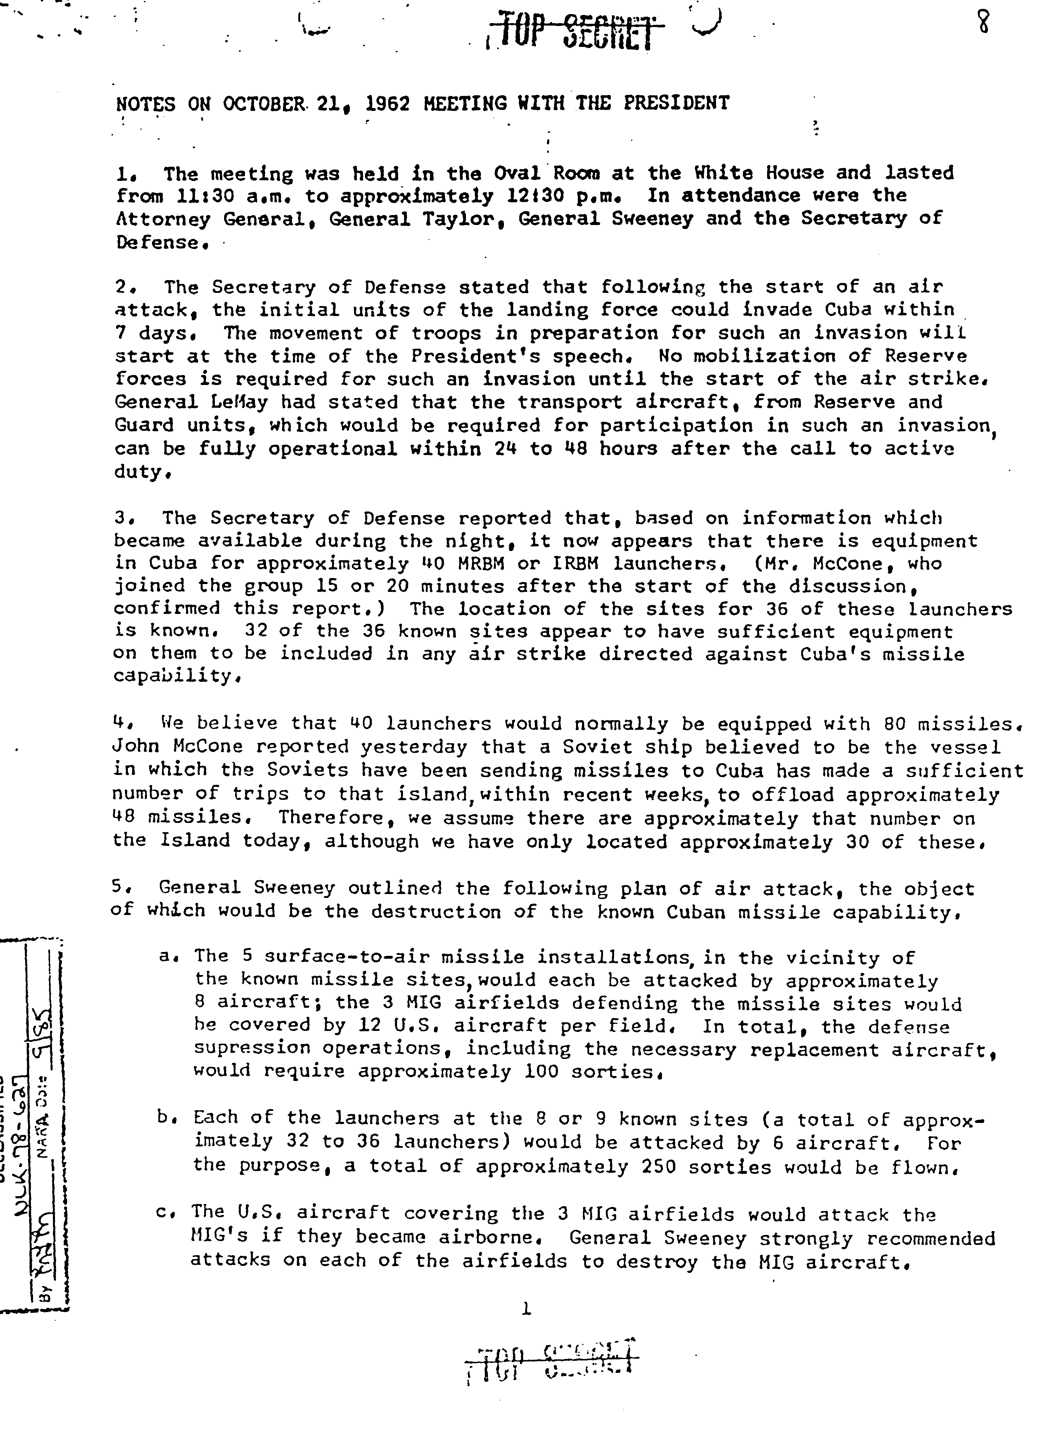
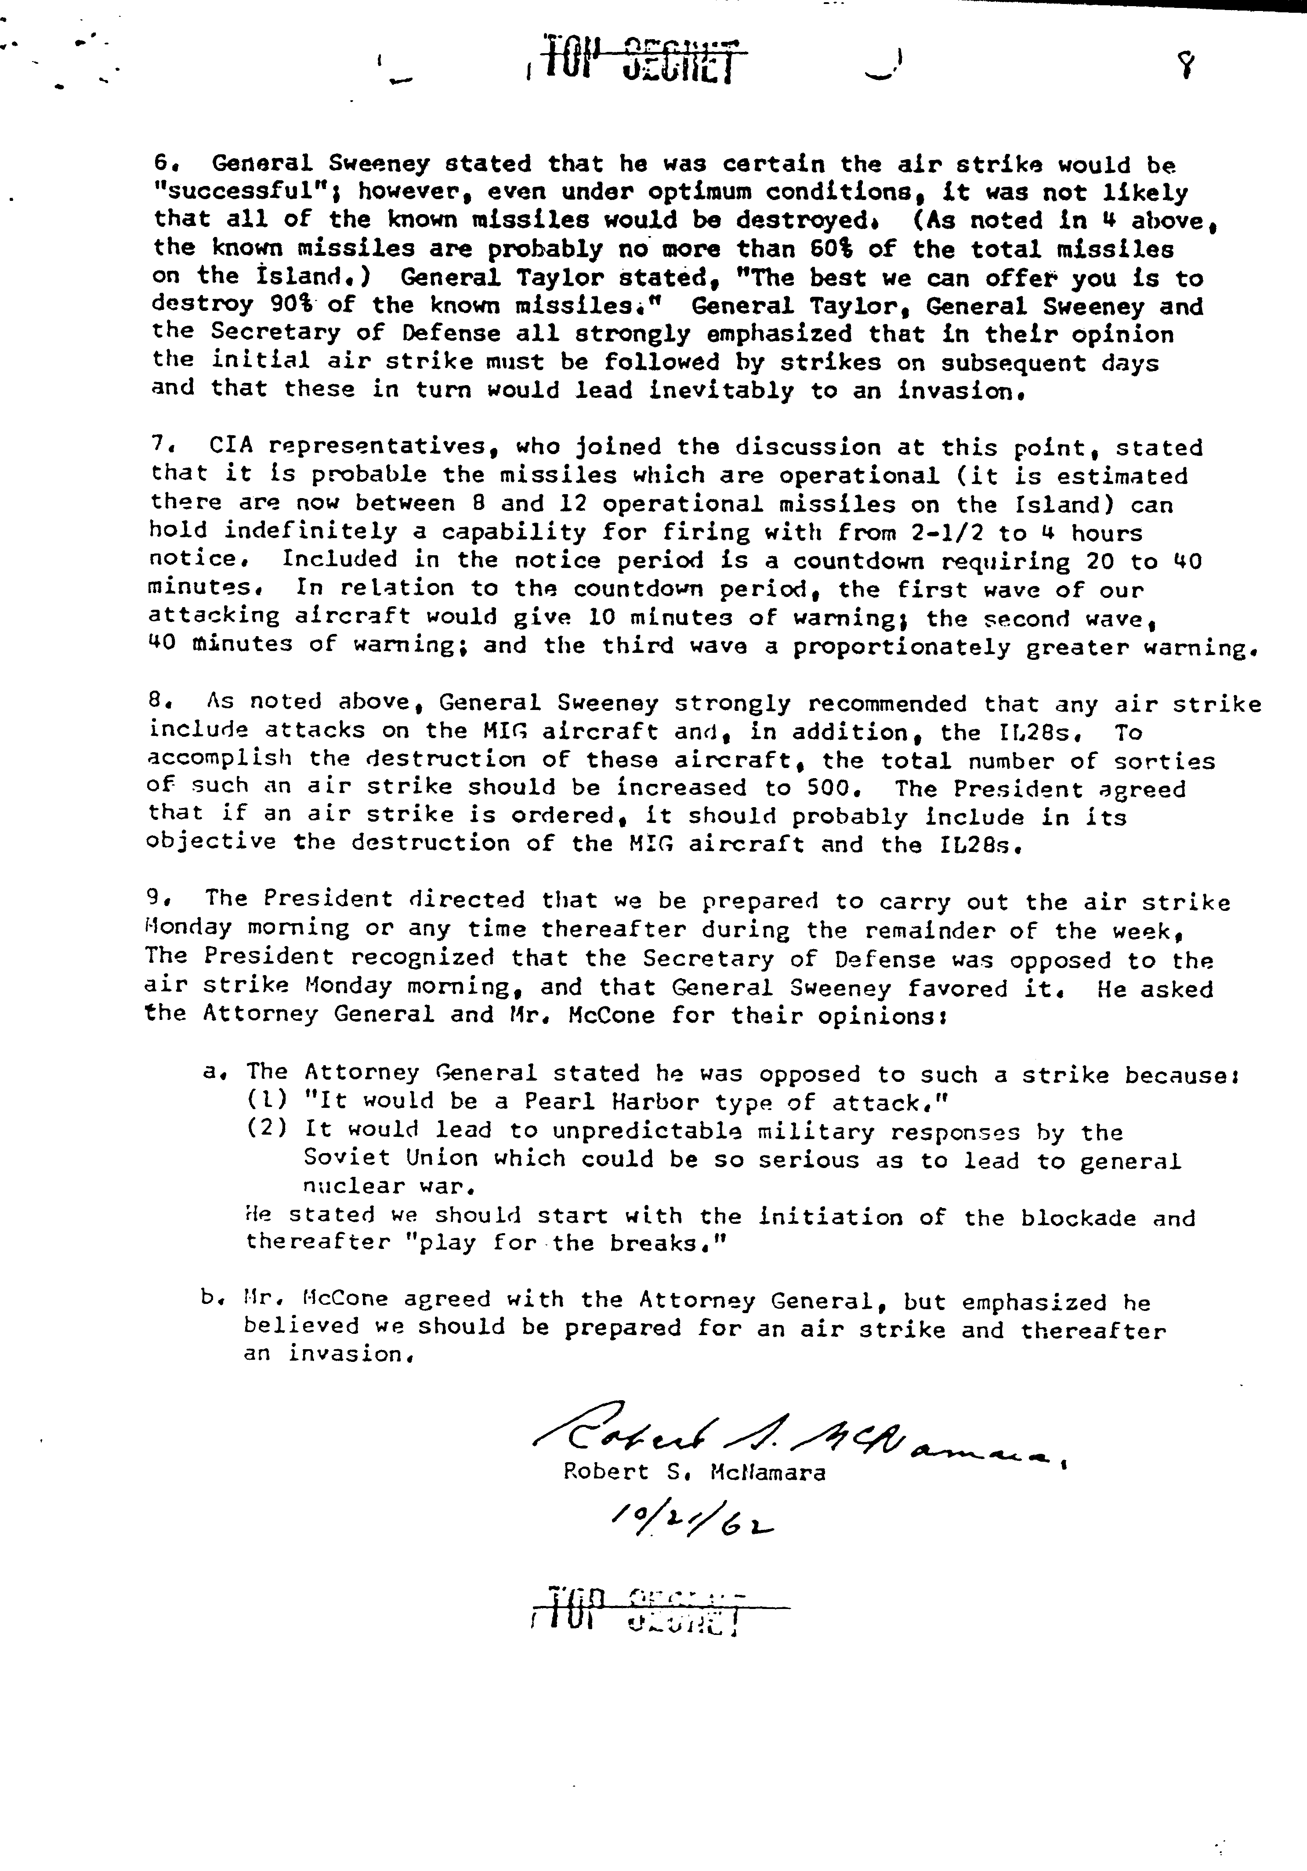
http://nsarchive.gwu.edu/nsa/cuba_mis_cri/19621021mcnam.pdf
Primary Source Three
Secretary Rusk opened the meeting by asking Mr. Johnson if he was ready to lay a program before the group. Mr. Johnson said that he was not.
Then ensued a military photographic intelligence briefing on installations in Cuba, presented by a CIA representative (Arthur Lundahl). Following this, Mr. McCone called on Mr. Cline to give the most recent intelligence estimate conclusions of the United States Intelligence Board. Mr. Cline did so on the basis of three papers which were distributed to the group. (As he started, Mr. Cline spoke of China by inadvertence instead of Cuba; a few moments later this was called to his attention and corrected.)
Secretary Rusk then said he thought there should be an exposition of the legal framework surrounding possible military measures by the United States, turned to me, and seemed about to call on me, when the Attorney General signalled and said “Mr. Katzenbach.” Secretary Rusk then called on the latter. Mr. Katzenbach said he believed the President had ample constitutional and statutory authority to take any needed military measures. He considered a declaration of war unnecessary. From the standpoint of international law, Mr. Katzenbach thought United States action could be justified on the principle of self-defense.
I said that my analysis ran along much the same lines. I did not think a declaration of war would improve our position, but indeed would impair it. I said that a defensive quarantine of Cuba would involve a use of force, and this had to be considered in relation to the United Nations Charter. The Charter contained a general prohibition against the use of force except in certain limited kinds of situation. One of these was “armed attack,” but the situation in Cuba did not constitute armed attack on any country. Another exception was collective action voted by the competent United Nations organ to deal with a situation under Chapter VII of the Charter. Obviously, no resolution could be obtained from the Security Council. And it seemed quite problematical whether we could obtain a recommendation from the General Assembly.
The Charter also contained Chapter VIII on regional arrangements. Article 52 provided that regional arrangements could deal with “such matters relating to the maintenance of international peace and security as are appropriate for regional action”. Thus a case could be made under the Charter for the use of force if it were sanctioned by the American Republics acting under the Rio Treaty. The Organ of Consultation, pursuant to Articles 6 and 8 of that Treaty, could recommend measures, including the use of armed force, to meet a situation endangering the peace of America. As to the prospects for securing the necessary two-thirds vote in the Organ of Consultation, Mr. Martin would have something to say about that.
If the contention were advanced that a defensive quarantine voted under the Rio Treaty constituted “enforcement action” under Article 53 of the United Nations Charter, and therefore required the authorization of the Security Council, we would be able to make a reasonably good argument to the contrary. While our ability to persuade seven members of the Security Council to vote with us on this issue might be uncertain, we would in any event be able to prevent a vote going against our position.
Mr. Martin then gave as his estimate that the United States could secure immediately a vote of 14 in the OAS. He thought the majority could be increased within 24 hours to 17 or perhaps even 18 or 19. He was hopeful in regard to Ecuador and Chile, and believed there was a good chance of getting Mexico. The Attorney General said the President would be placed in an impossible position if we went to the OAS and then failed to get the necessary votes, or if there were a delay. He asked if we could be perfectly sure of the outcome before seeking OAS concurrence. Mr. Martin said he hated to guarantee anything, but he had a lot of confidence about this. You couldn’t go to the American Republics in advance without loss of security, but he felt that a last-minute approach to heads of state, laying the situation on the line, would produce the votes. The Attorney General again expressed his great concern at the possibility of a slip.
There followed a discussion covering the meeting held the night before with the President. One participant looked back on the meeting as having arrived at a tentative conclusion to institute a blockade, and thought the President had been satisfied at the consensus by then arrived at among his advisers. General Taylor quickly indicated that he had not concurred and that the Joint Chiefs had reserved their position.
Mr. Bundy then said that he had reflected a good deal upon the situation in the course of a sleepless night, and he doubted whether the strategy group was serving the President as well as it might, if it merely recommended a blockade. He had spoken with the President this morning, and he felt there was further work to be done. A blockade would not remove the missiles. Its effects were uncertain and in any event would be slow to be felt. Something more would be needed to get the missiles out of Cuba. This would be made more difficult by the prior publicity of a blockade and the consequent pressures from the United Nations for a negotiated settlement. An air strike would be quick and would take out the bases in a clean surgical operation. He favored decisive action with its advantages of surprises and confronting the world with a fait accompli.
Secretary Rusk asked Mr. Acheson for his views. Mr. Acheson said that Khrushchev had presented the United States with a direct challenge, we were involved in a test of wills, and the sooner we got to a showdown the better. He favored cleaning the missile bases out decisively with an air strike. There was something else to remember. This wasn’t just another instance of Soviet missiles aimed at the United States. Here they were in the hands of a madman whose actions would be perfectly irresponsible; the usual restraints operating on the Soviets would not apply. We had better act, and act quickly. So far as questions of international law might be involved, Mr. Acheson agreed with Mr. Katzenbach’s position that self-defense was an entirely sufficient justification. But if there were to be imported a qualification or requirement of approval by the OAS, as apparently suggested by Mr. Meeker, he could not go along with that.
Secretary Dillon said he agreed there should be a quick air strike. Mr. McCone was of the same opinion.
General Taylor said that a decision now to impose a blockade was a decision to abandon the possibility of an air strike. A strike would be feasible for only a few more days; after that the missiles would be operational. Thus it was now or never for an air strike. He favored a strike. If it were to take place Sunday morning, a decision would have to be made at once so that the necessary preparations could be ordered. For a Monday morning strike, a decision would have to be reached tomorrow. Forty-eight hours’ notice was required.
Secretary McNamara said that he would give orders for the necessary military dispositions, so that if the decision were for a strike the Air Force would be ready. He did not, however, advocate an air strike, and favored the alternative of blockade.
Under Secretary Ball said that he was a waverer between the two courses of action.
The Attorney General said with a grin that he too had had a talk with the President, indeed very recently this morning. There seemed to be three main possibilities as the Attorney General analyzed the situation: one was to do nothing, and that would be unthinkable; another was an air strike; the third was a blockade. He thought it would be very, very difficult indeed for the President if the decision were to be for an air strike, with all the memory of Pearl Harbor and with all the implications this would have for us in whatever world there would be afterward. For 175 years we had not been that kind of country. A sneak attack was not in our traditions. Thousands of Cubans would be killed without warning, and a lot of Russians too. He favored action, to make known unmistakably the seriousness of United States determination to get the missiles out of Cuba, but he thought the action should allow the Soviets some room for maneuver to pull back from their over-extended position in Cuba.
Mr. Bundy, addressing himself to the Attorney General, said this was very well but a blockade would not eliminate the bases; an air strike would.
I asked at this point: who would be expected to be the government of Cuba after an air strike? Would it be anyone other than Castro? If not, would anything be solved, and would we not be in a worse situation than before? After a pause, Mr. Martin replied that, of course, a good deal might be different after a strike, and Castro might be toppled in the aftermath. Others expressed the view that we might have to proceed with invasion following a strike. Still another suggestion was that US armed forces seize the base areas alone in order to eliminate the missiles. Secretary McNamara thought this a very unattractive kind of undertaking from the military point of view.
Toward one o’clock Secretary Rusk said he thought this group could not make the decision as to what was to be done; that was for the President in consultation with his constitutional advisers. The Secretary thought the group’s duty was to present to the President, for his consideration, fully staffed-out alternatives. Accordingly, two working groups should be formed, one to work up the blockade alternative and the other to work up air strike. Mr. Johnson was designated to head the former, and Mr. Bundy the latter. Mr. Johnson was to have with him Ambassador Thompson, Deputy Secretary Gilpatric, Mr. Martin, Mr. Nitze, and Mr. Meeker. Mr. Bundy was to have Secretary Dillon, Mr. Acheson, and General Taylor. Mr. McCone, when asked to serve with the air strike group, begged off on the ground that his position and duties on the US Intelligence Board made it undesirable for him to participate in the working group. Mr. Katzenbach was detailed to the Johnson group, later visiting the Bundy group to observe and possibly serve as a devil’s advocate.
Mr. Sorensen commented that he thought he had absorbed enough to start on the draft of a speech for the President. There was some inconclusive discussion on the timing of such a speech, on the danger of leaks before then, and on the proper time for meeting with the President once more, in view of his current Western campaign trip.
Before the whole group dispersed, Ambassador Thompson said the Soviets attached importance to questions of legality and we should be able to present a strong legal case. The Attorney General, as he was about to leave the room, said he thought there was ample legal basis for a blockade. I said: yes, that is so provided the Organ of Consultation under the Rio Treaty adopted an appropriate resolution. The Attorney General said: “That’s all political; it’s not legal.” On leaving the room, he said to Mr. Katzenbach, half humorously: “Remember now, you’re working for me.”
The two groups met separately until four o’clock. They then reconvened and were joined once more by the cabinet officers who had been away in the earlier afternoon.
The Johnson group scenario, which was more nearly complete and was ready earlier, was discussed first. Numerous criticisms were advanced. Some were answered; others led to changes. There was again a discussion of timing, now in relation to a Presidential radio address. Mr. Martin thought Sunday might be too early, as it would be virtually impossible to get to all the Latin American heads of state on Sunday. Ambassador Thompson made the point that 24 hours must be allowed to elapse between announcement of the blockade and enforcement, so as to give the Soviet Government time to get instructions to their ship captains.
Approximately two hours were spent on the Johnson scenario. About 6 o’clock the Bundy approach was taken up, its author saying, “It’s been much more fun for us up to this point, since we’ve had a chance to poke holes in the blockade plan; now the roles will be reversed.” Not much more than half an hour was spent on the Bundy scenario.
More than once during the afternoon Secretary McNamara voiced the opinion that the US would have to pay a price to get the Soviet missiles out of Cuba. He thought we would at least have to give up our missile bases in Italy and Turkey and would probably have to pay more besides. At different times the possibility of nuclear conflict breaking out was referred to. The point was made that, once the Cuban missile installations were complete and operational, a new strategic situation would exist, with the United States more directly and immediately under the gun than ever before. A striking Soviet military push into the Western Hemisphere would have succeeded and become effective. The clock could not be turned back, and things would never be the same again. During this discussion, the Attorney General said that in looking forward into the future it would be better for our children and grandchildren if we decided to face the Soviet threat, stand up to it, and eliminate it, now. The circumstances for doing so at some future time were bound to be more unfavorable, the risks would be greater, the chances of success less good.
Secretary Rusk, toward the end of the afternoon, stated his approach to the problem as follows: the US needed to move in a way such that a planned action would be followed by a pause in which the great powers could step back from the brink and have time to consider and work out a solution rather than be drawn inexorably from one action to another and escalate into general nuclear war. The implication of his statement was that he favored blockade rather than strike.
In the course of the afternoon discussion, the military representatives, especially Secretary McNamara, came to expressing the view that an air strike could be made some time after the blockade was instituted in the event the blockade did not produce results as to the missile bases in Cuba. The Attorney General took particular note of this shift, and toward the end of the day made clear that the firmly favored blockade as the first step; other steps subsequently were not precluded and could be considered; he thought it was now pretty clear what the decision should be.
At about six-thirty Governor Stevenson came into the room. After a few minutes, Secretary Rusk asked him if he had some views on the question of what to do. He replied: “Yes, most emphatic views.” When queried as to them, he said that in view of the course the discussion was taking he didn’t think it was necessary to express them then. When asked: “But you are in favor of blockade, aren’t you?”, he answered affirmatively. He went on to say he thought we must look beyond the particular immediate action of blockade; we need to develop a plan for solution of the problem—elements for negotiation designed to settle the current crisis in a stable and satisfactory way and enable us to move forward on wider problems; he was working on some ideas for a settlement. One possibility would be the demilitarization of Cuba under effective international supervision, perhaps accompanied by neutralization of the island under international guaranties and with UN observers to monitor compliance.
Once again there was discussion of when another meeting with the President should be held. It was generally agreed that the President should continue on his trip until Sunday morning. He would be reachable by telephone prior to that time.
The meeting broke up about seven o’clock.

http://teachingamericanhistory.org/library/document/record-of-meeting-during-the-cuban-missile-crisis/

Primary Source Four
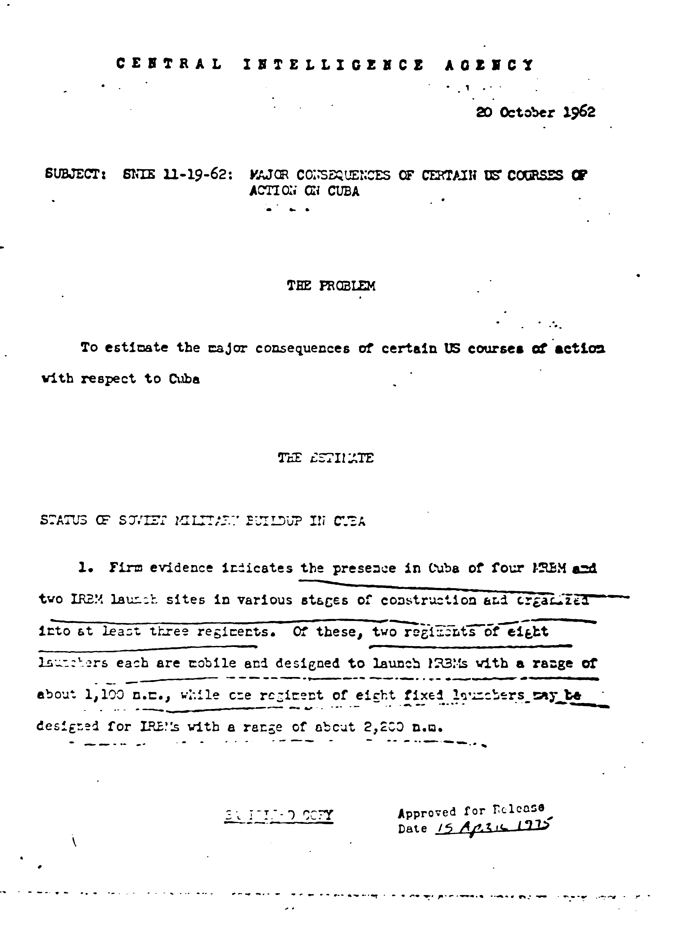

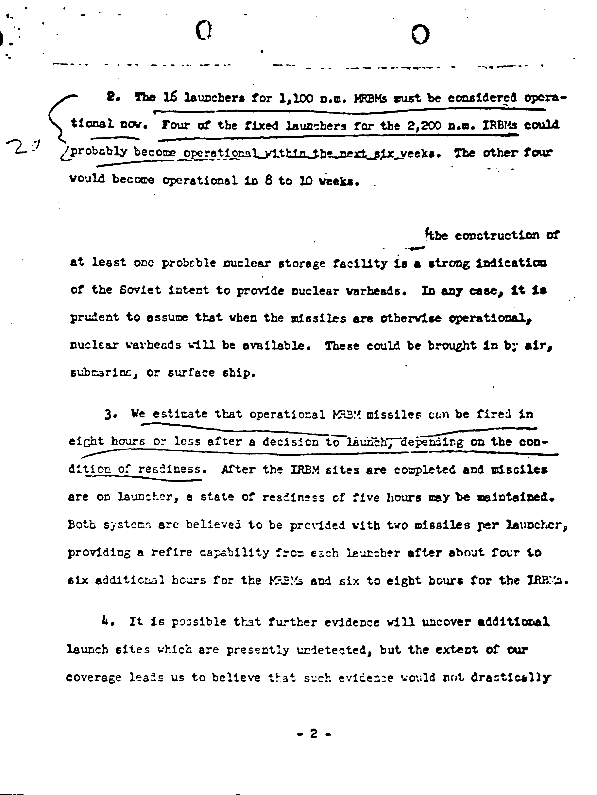

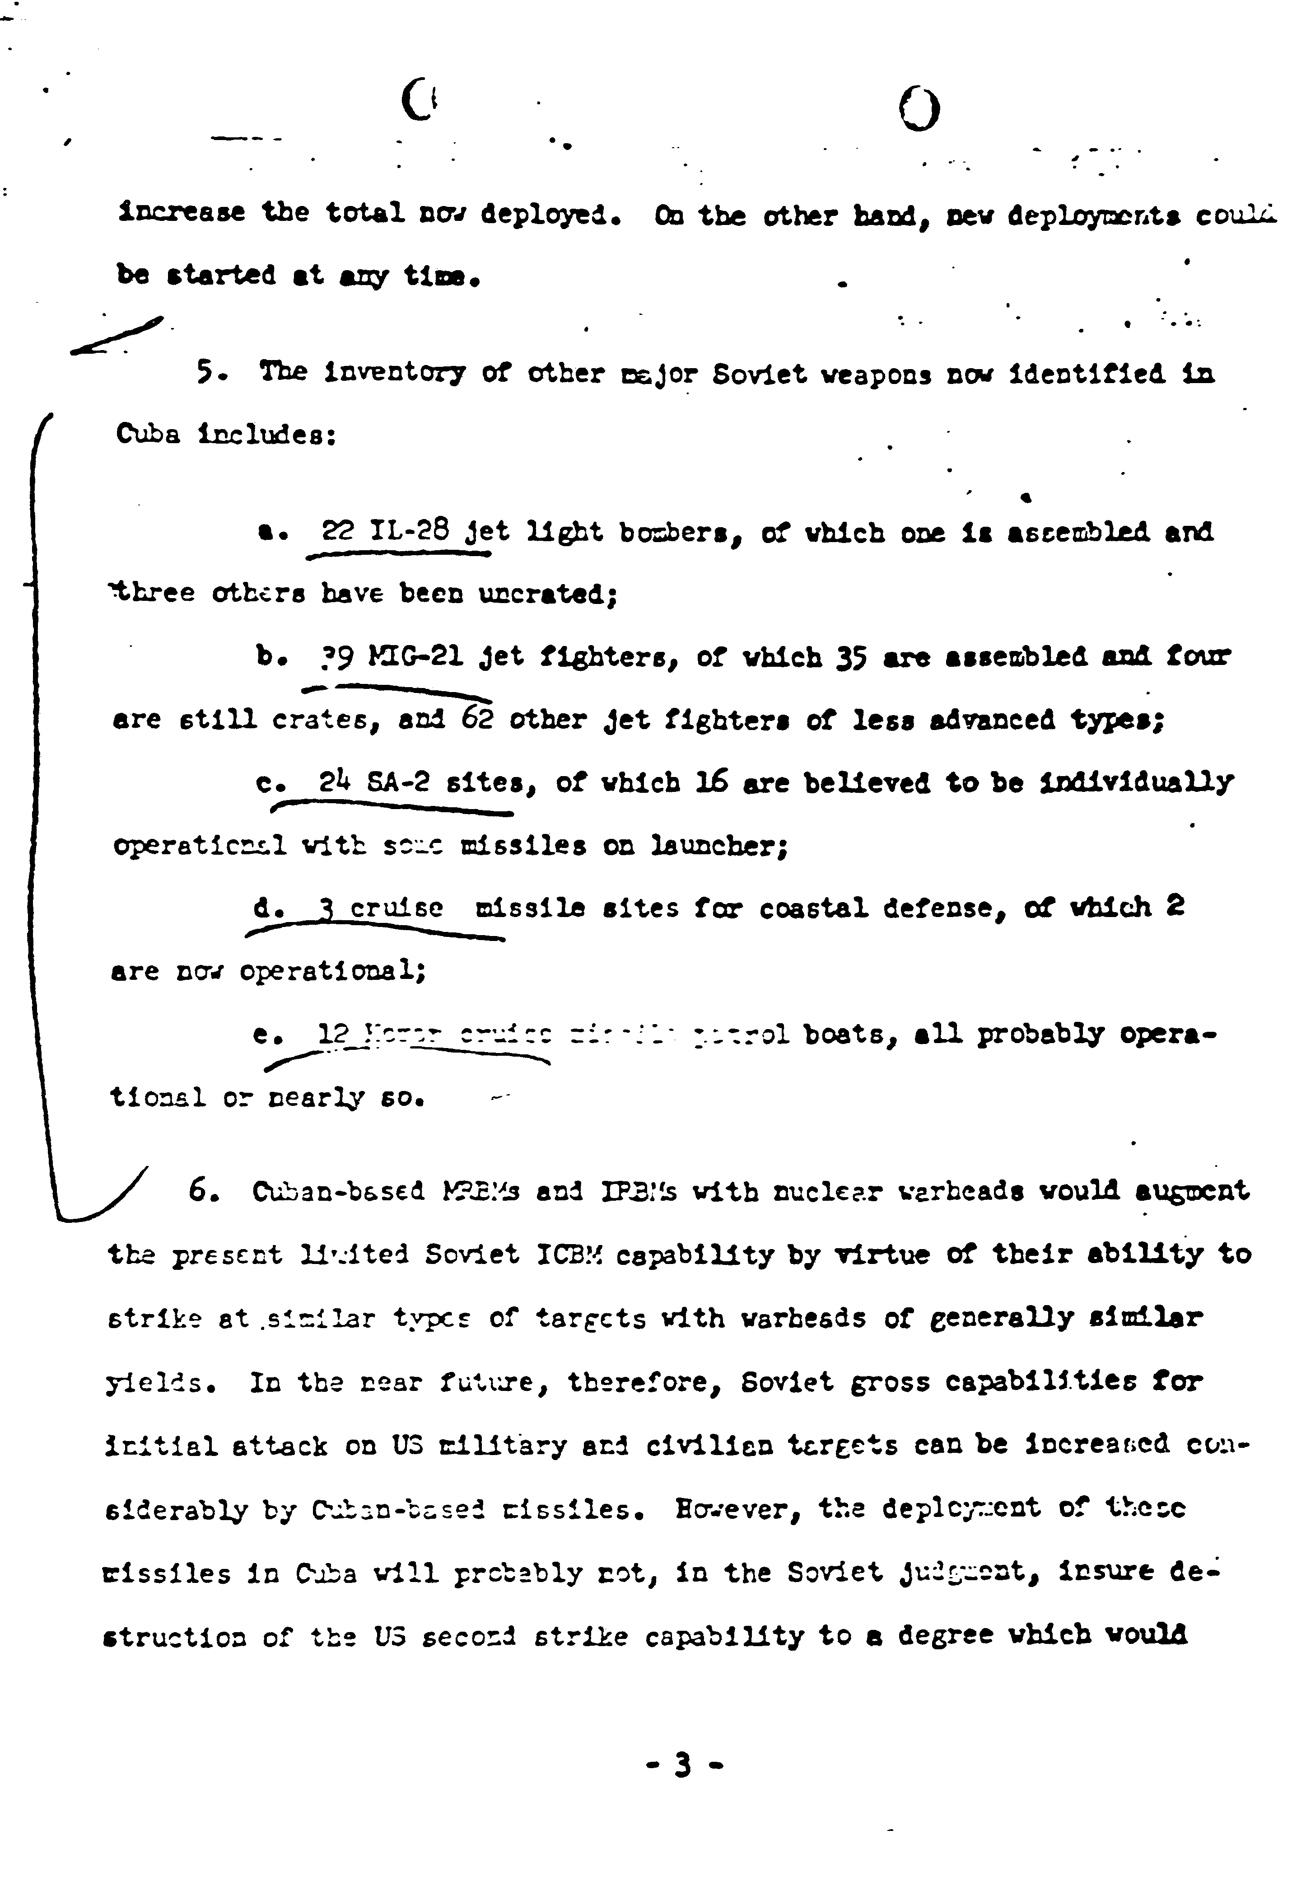

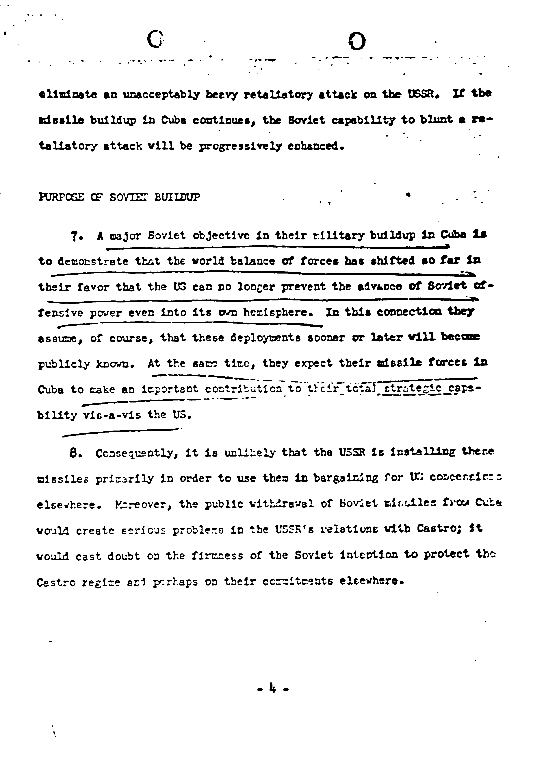

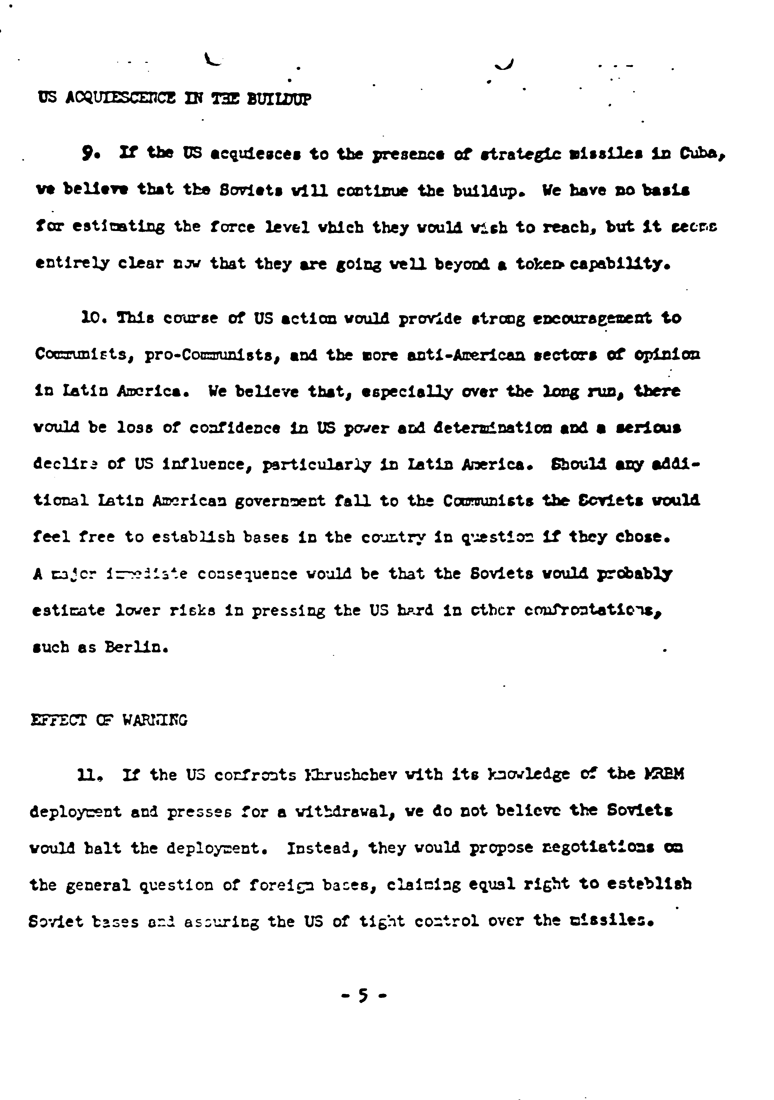

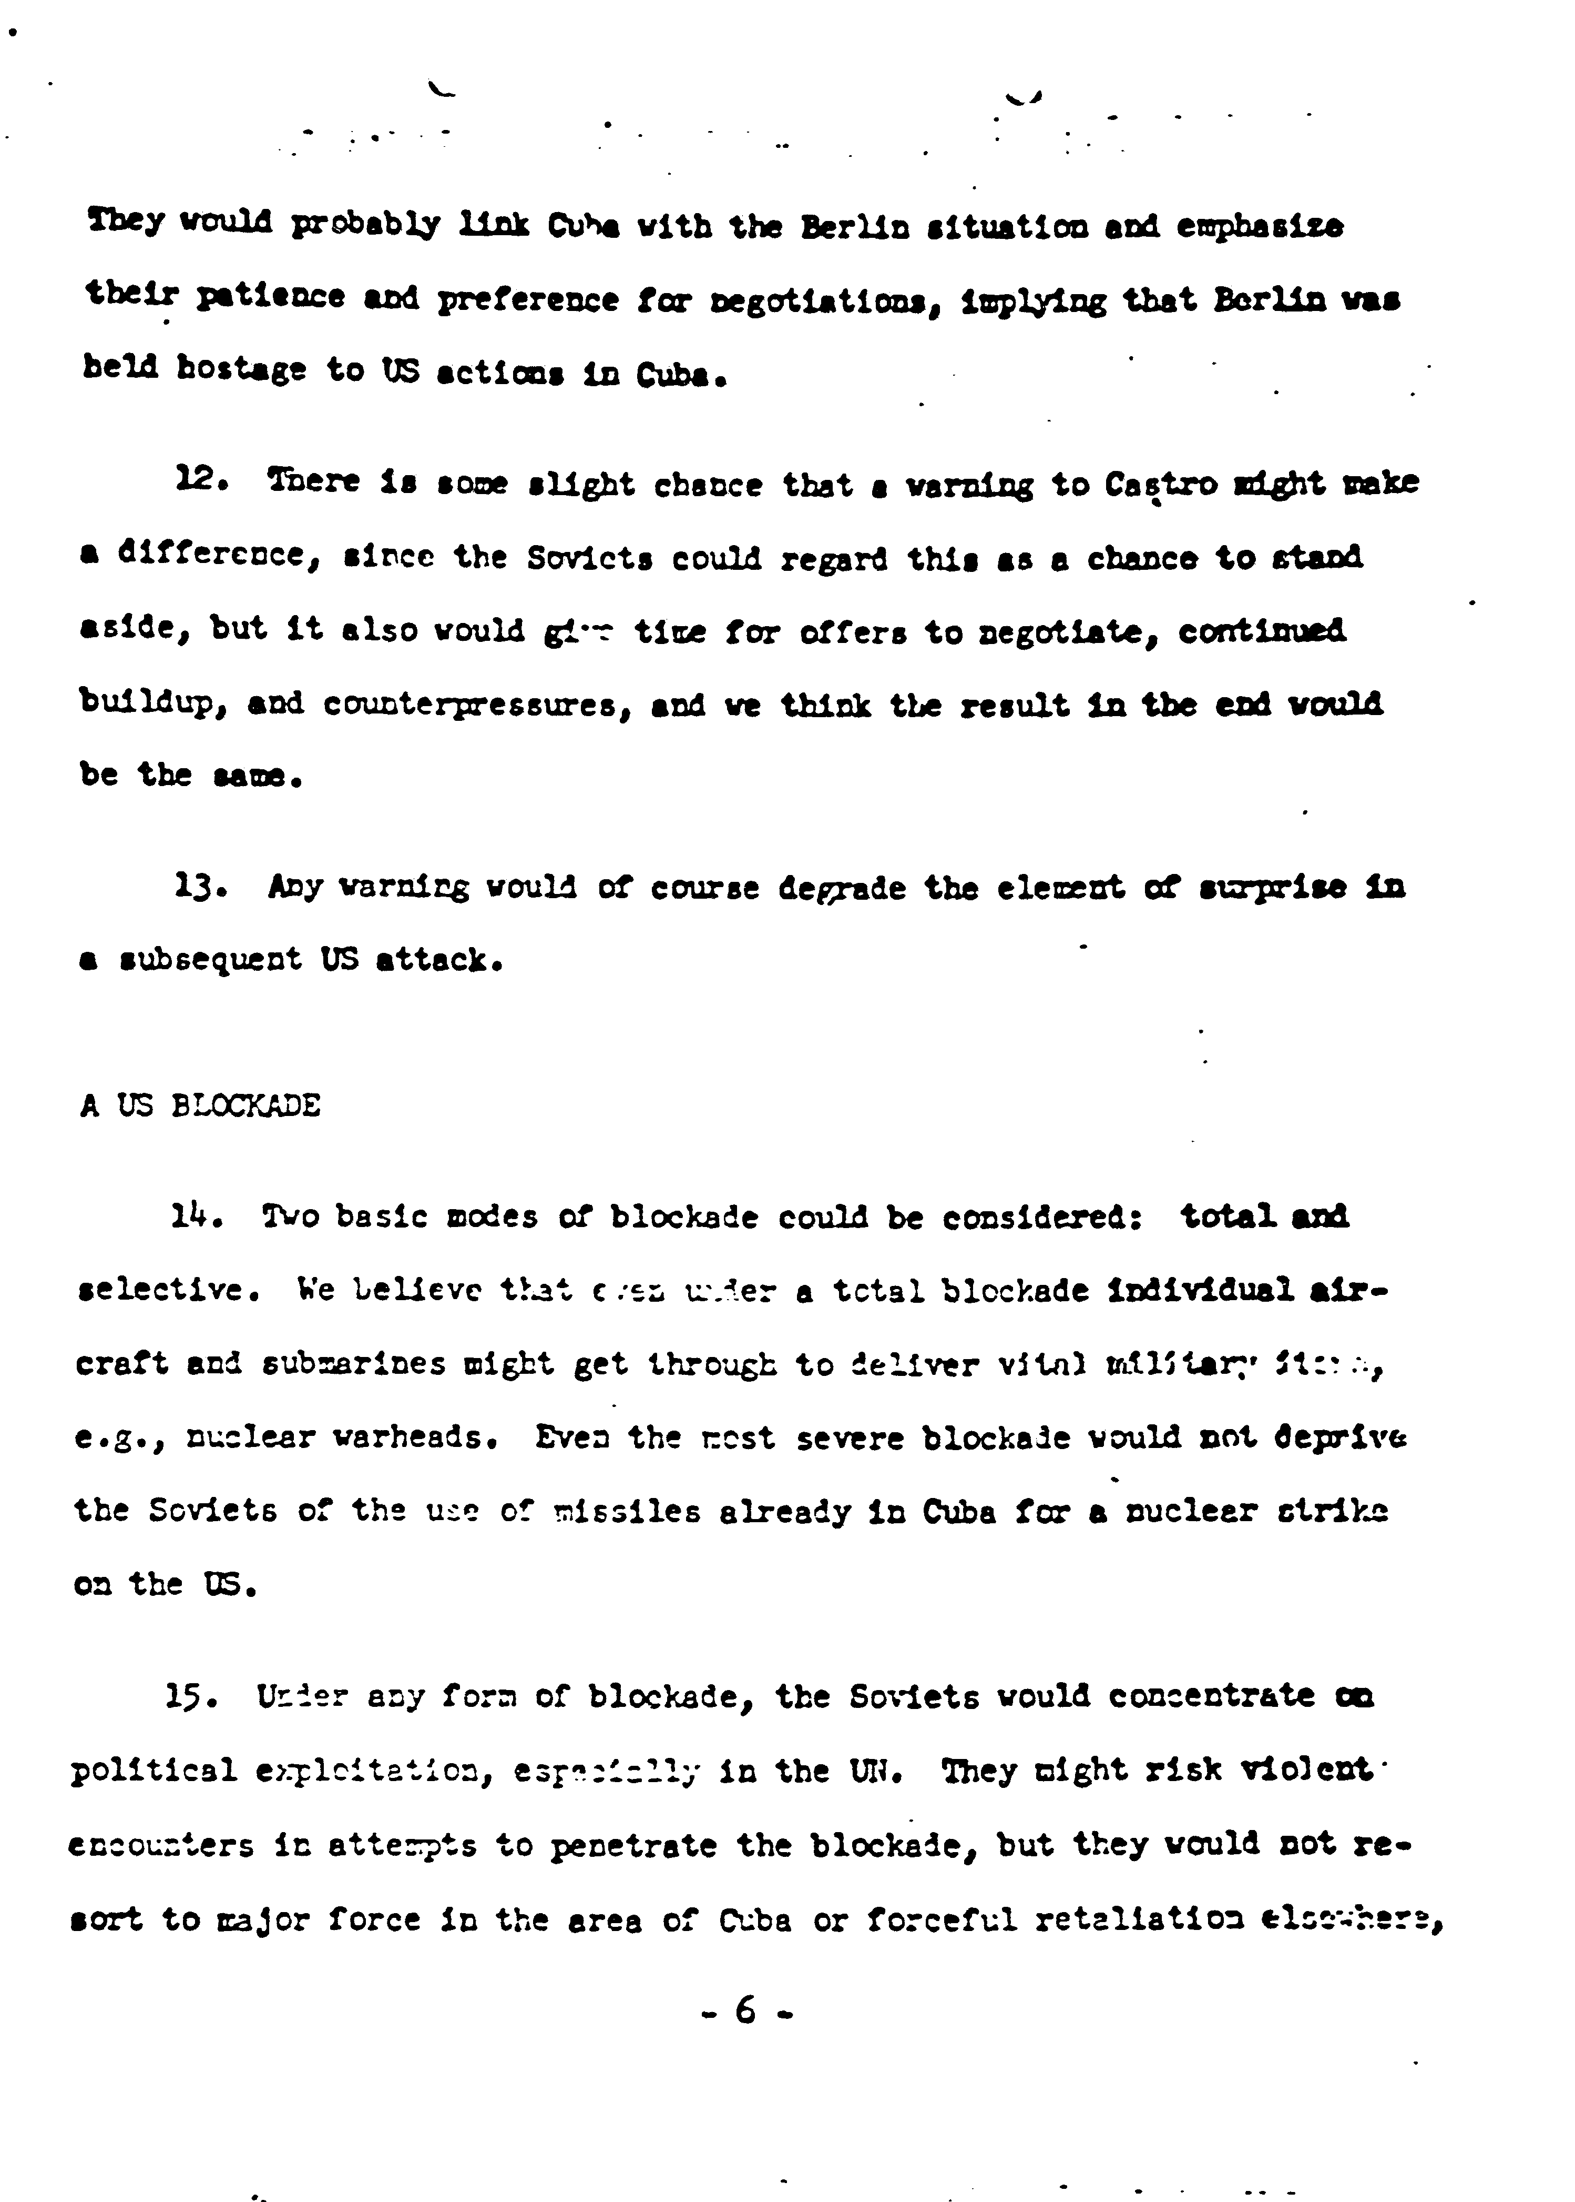

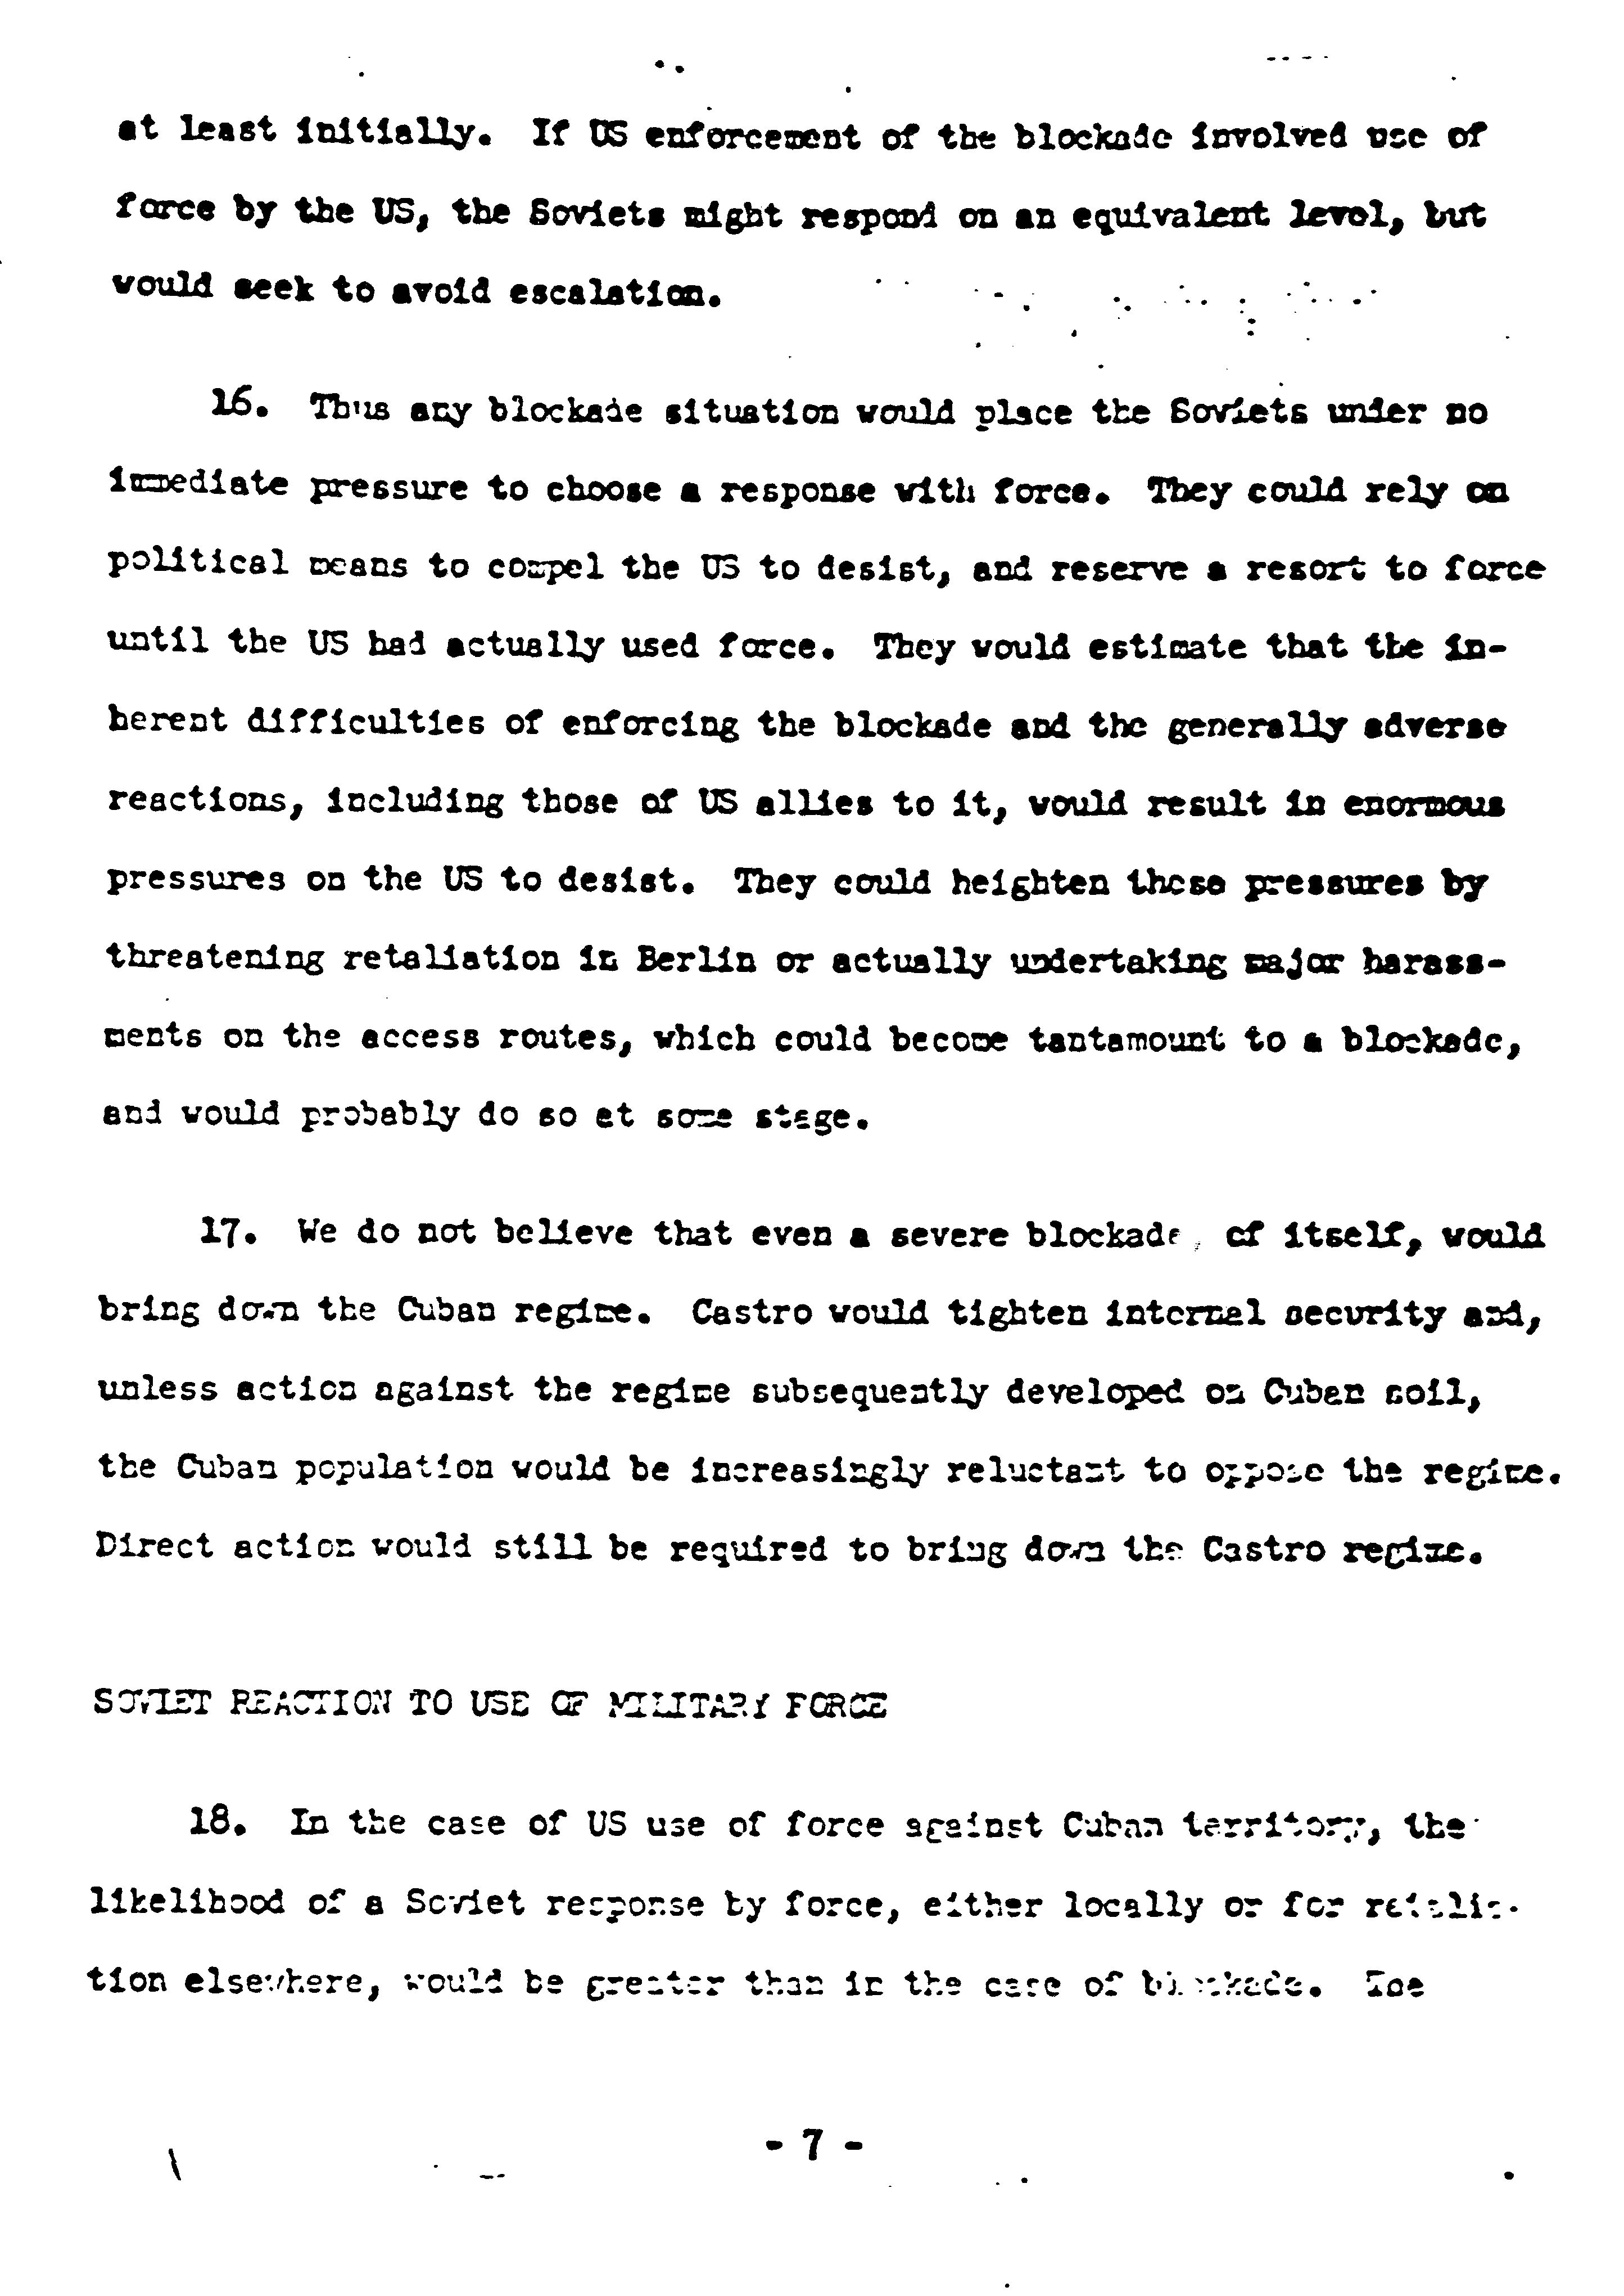

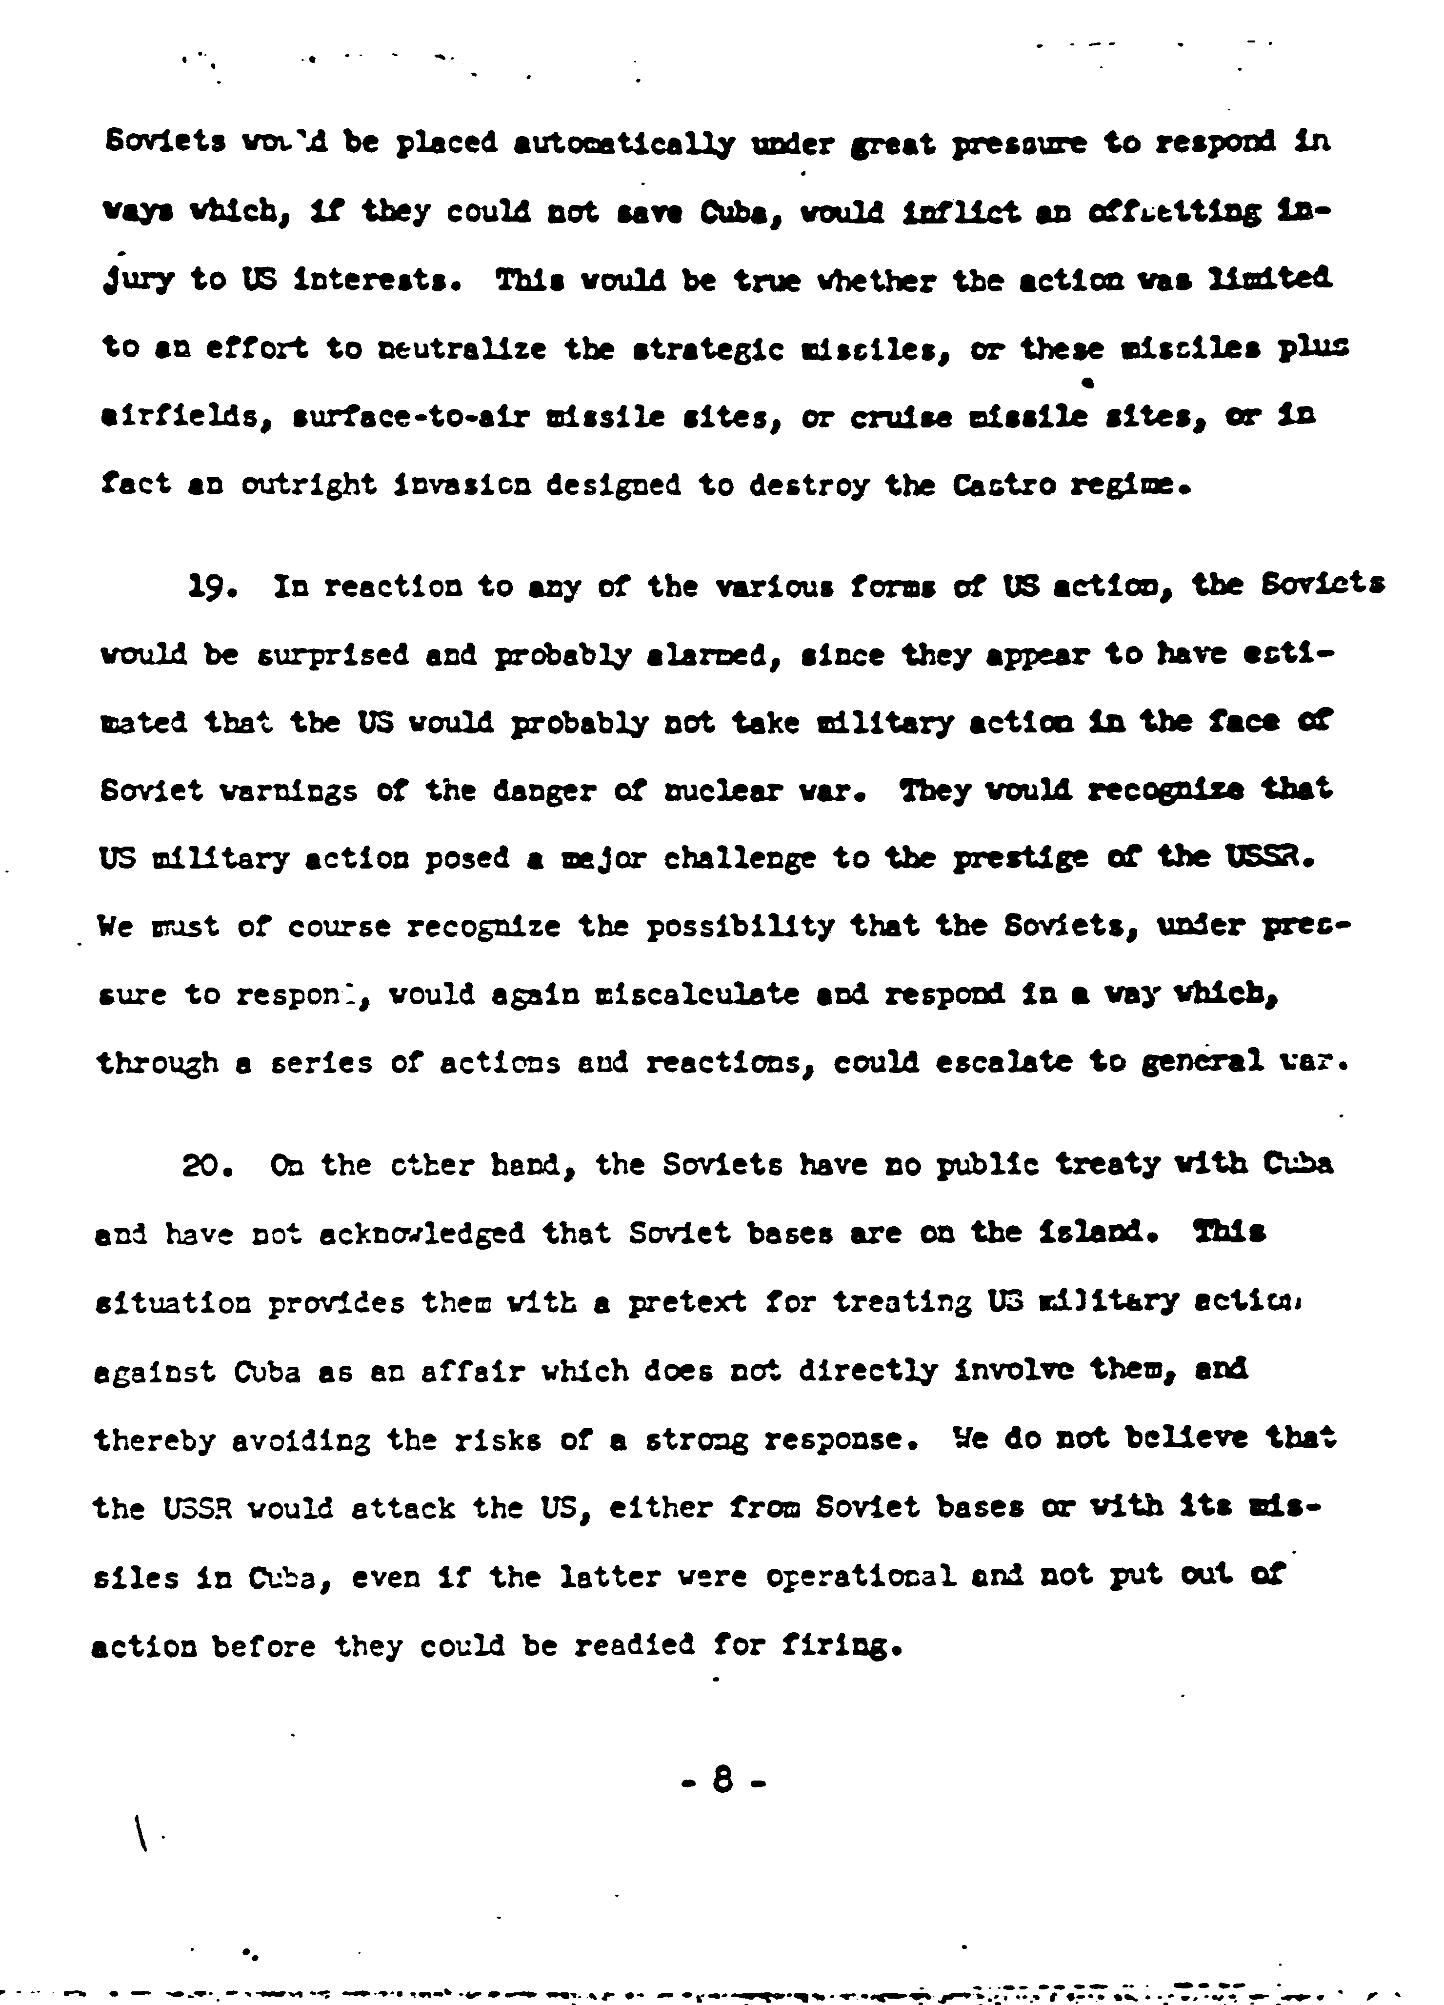

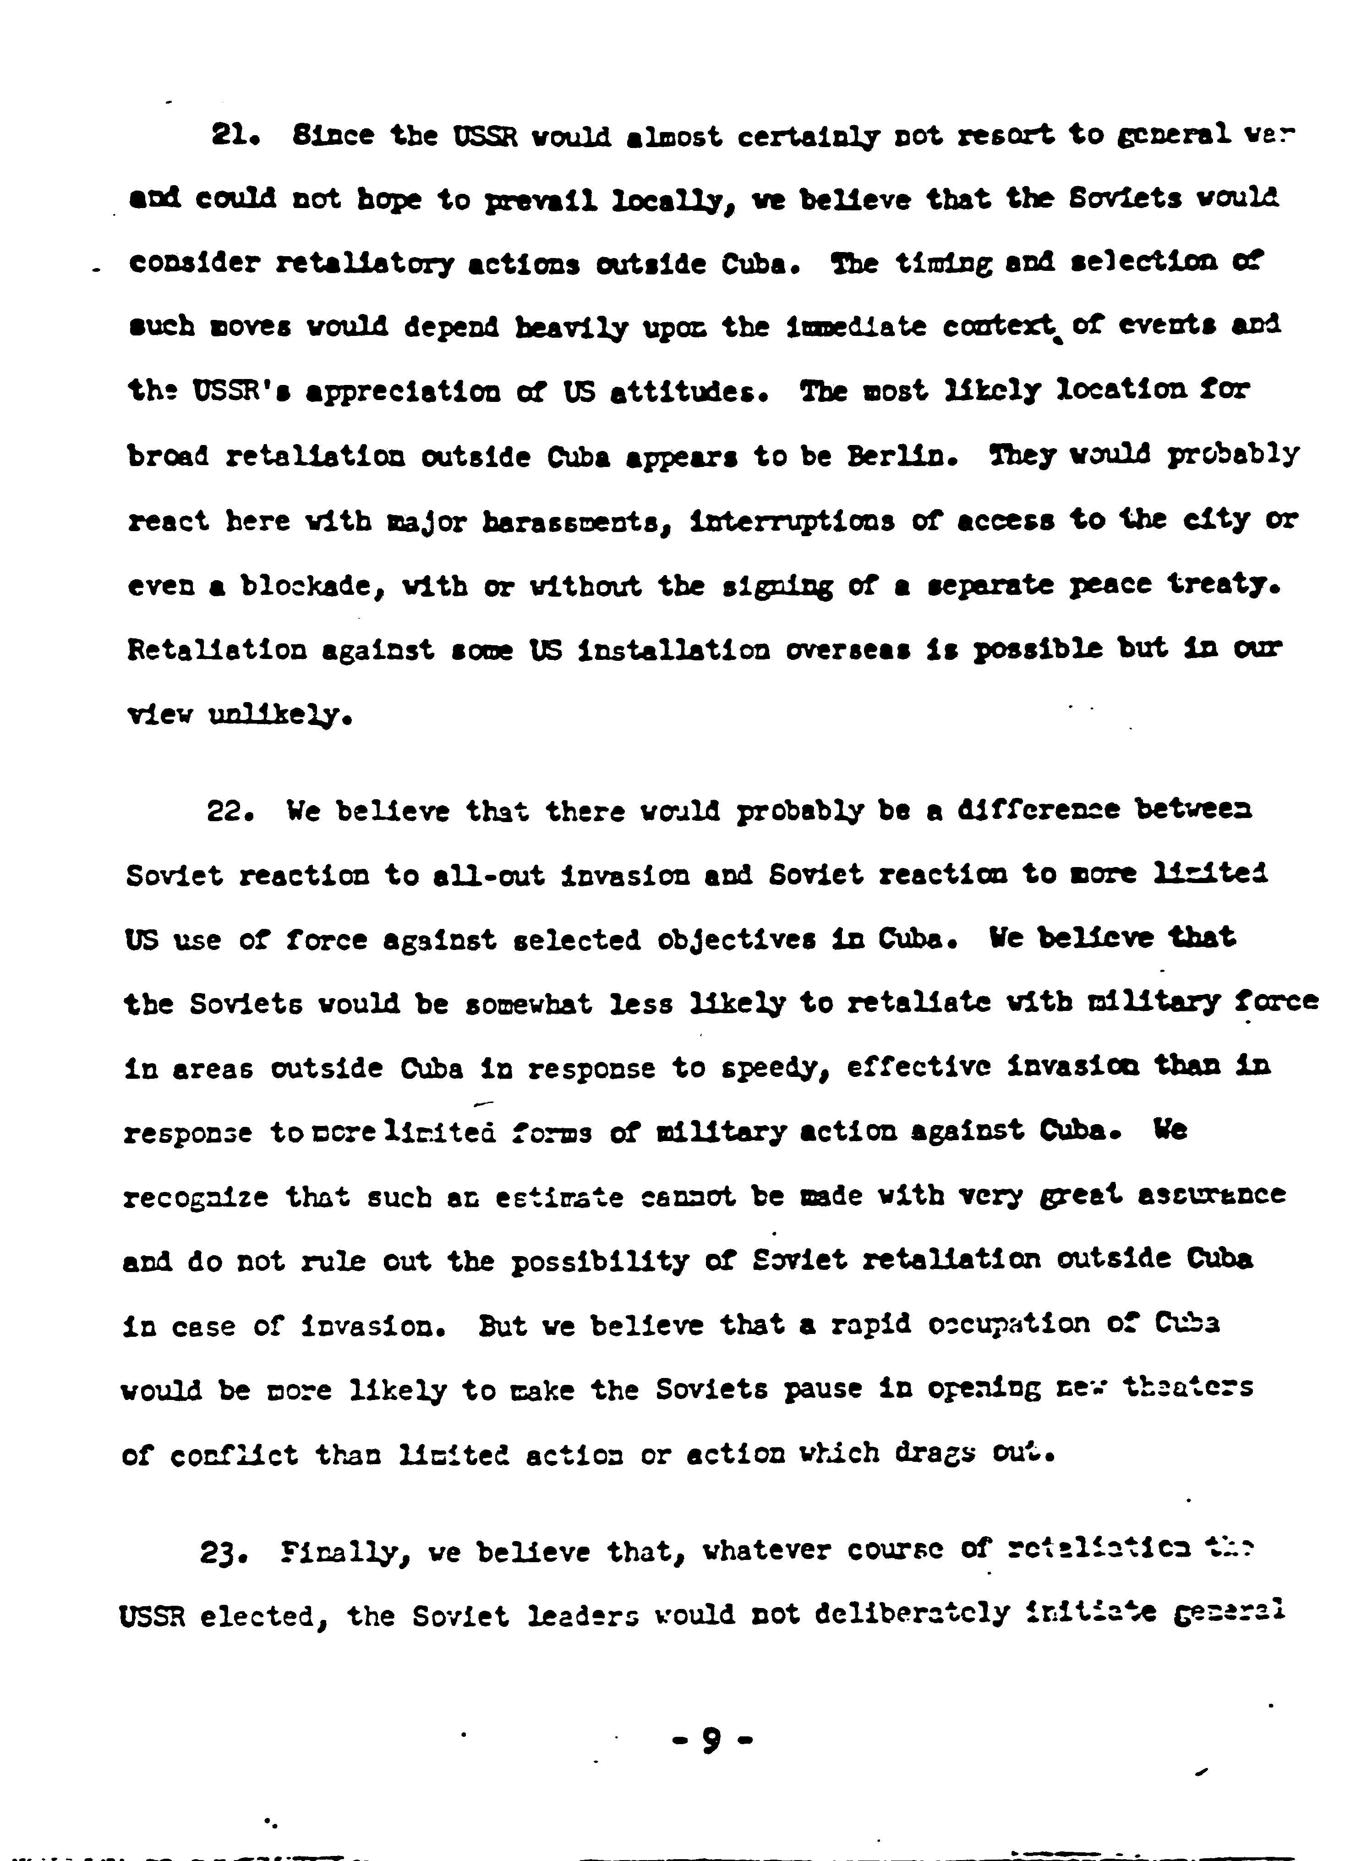

http://nsarchive.gwu.edu/nsa/cuba_mis_cri/19621020cia.pdf
Primary Source Five

Typed transcript of a handwritten summary of the day’s events, October 23, 1962.

---------------------------------------------------------------------------------------------------------------------------------------------

Cuban Missile Crisis
October 23, 1962: US announced USSR had started building aggressive missile bases in Cuba.

President Kennedy ordered US naval and air forces to establish immediate “quarantine” (partial blockade) of Cuba to prevent further delivery of aggressive [sic] weapons aboard Soviet-bloc or any other ships.

USSR said US action could end in thermonuclear war; warning that Soviet ships would not submit to search.

UN Security Council convened; Acting Secretary A Thant pleaded for negotiation.

Kennedy charged Soviet-Cuban action had upset precarious status quo which had long existed between East & West in regard to nuclear weapons.

https://www.nsa.gov/public_info/_files/cuban_missile_crisis/23_october_summary.pdf
Primary Source Six
Introduction
President Kennedy's foreign policy issues continued to worsen after the failed Bay of Pigs invasion. As a result of this perceived aggression against Communist expansion, the Soviets constructed an eleven foot tall, cement wall encircling the isolated city of West Berlin. Not wanting to risk a renewed conflict in the heart of Europe, Kennedy remarked that "a wall is a hell of a lot better than a war." Tensions reached a boiling point when in the fall of 1962 American spy plans reported the discovery of Soviet nuclear weapons and missile silos on the island of Cuba, only ninety miles from Florida and well within range for a nuclear strike on all major U.S. cities. The text below is excerpted from a report presented to President Kennedy and his Executive Committee on October 25, 1962. This "Scenario for Airstrike against Offensive Missile Bases and Bombers in Cuba," weighs the pros and cons of a potential American strike to remove Soviet weapons and influence from the island of Cuba.

ADVANTAGES:
- Carries out President's pledge to eliminate offensive threat to U.S. and Hemisphere from Cuba and avoids any erosion of U.S. momentum and position. The pledge carried out shows that U.S. has will to fight and to protect vital interests (of great importance vis-a-vis Berlin).
- Since directed at offensive weapons, keeps issue focused on Soviet nuclear presence in Cuba in defiance of (Organization of American States] and majority of Security Council (United Nations].
- Sharp, possible one time action, may carry smaller risks of further escalation than a series of confrontations over a period of time. Soviet decision to risk major war unlikely to be decisively affected by this action in an area non-vital to the Soviets.
- Prompt action will avoid danger of a growth of hands-off Cuba movement throughout Latin America which might make it increasingly difficult to strike at offensive weapons. Present willingness of Latin Americans to support strong action probably cannot be maintained indefinitely.
- Signals clearly that U.S. not prepared to bargain for bases in Cuba for positions in Berlin, NATO, and elsewhere.
- It could demonstrate to Cubans, Castro and others, the weakness of Soviet position in Cuba. In the absence of a strong Soviet reaction in defense of Cuba, we would start the process of disenchantment and disaffection requisite to undermining Castro and CUban reliance on the Soviet Union. We would also weaken any tendencies to rely on Soviets elsewhere in the world.
- Removes military threat to U.S. from Cuban territory.
- Denies Khrushchev a possible cheap victory through successful maintenance of offensive weapons in Cuba.

DISADVANTAGES:
- This action may force Khrushchev to react strongly and could result in some type of war. Khrushchev will not order launch of a missile from Cuba unless he is ready for war essentially on other grounds. There is greater likelihood of a riposte in kind. However, it is unlikely that the risks of major war are greater than through escalation of a blockade.
- There is remote possibility that some local Soviet commander in Cuba may order firing of a missile.
- Adverse effect on U.S. image of initiation of use of force against a small country. This can be minimized by making attack selective and focused on Soviet offensive weapons. At same time there would be positive increments to our image from demonstration of clear willingness to take on Soviets in protection of our vital interests.
- Unless carefully handled could damage long-range U.S.-Cuban relations.
- May not totally eliminate offensive weapons thus calling for follow up attacks and/or invasion, unless full and unlimited international inspection is agreed to.

Engel, Jeffrey A., Mark Atwood. Lawrence, and Andrew Preston, eds.America in the World: A History in Documents from the War with Spain to the War on Terror. Princeton, NJ: Princeton UP, 2014. Print.
Report by advisory group led by Douglas Dillon, "Scenario for Airstrike against Offensive Missile Bases and Bombers in Cuba," Octtober 25, 1962 Digital National Security Archive, item number CC01334, Document Set: the Cuban Missile Crisis, 1962, ed. Laurence Chang (Alexandria, Va.: National Security Archive and Chadwyck-Healey Inc., 1990).

