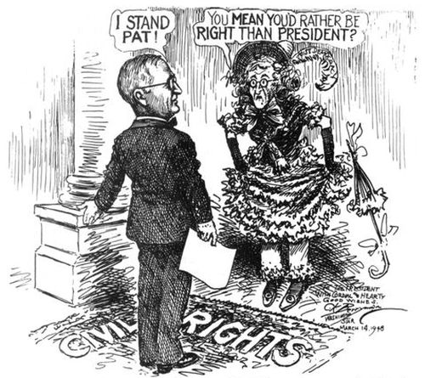
The Long, Unsteady March
Name: __________________________
8th Grade History

Sequencing Events – 10%
Place the events below in the correct sequential order by placing the corresponding numbers in the spaces provided.

1. passage of the 19th Amendment
2. Isaac Woodard’s ordeal
3. Executive Order 9981 issued
4. Truman’s speech to the NAACP
5. Founding of the NAACP

_____ _____ _____ _____ _____

Summarizing a Primary Source – 50%
Read, review, identify keywords, and summarize documents one and two on the following pages. You may underline your keywords and list your Top 5 & Why at the bottom of the page. Please compose your summary on a separate sheet of loose-leaf paper. You do not have to summarize document three.

Document One
“Young gentlemen, I am glad to welcome you home again after months of absence in a foreign land in obedience to the call of your country – glad that you returned to us without any serious casualties…
We, who remained at home, followed you while you were away, with the deepest interest; and, our hearts burned with indignation when tidings came to us, as it did from time to time, of the manner in which you were treated by those over you, from whom you had every reason … to expect decent, humane treatment, instead of the treatment that was accorded you. The physical hardships, incident to a soldier’s life in times of war, are trying enough, are hard enough to bear … To add to these insults, the studied insults that were heaped upon you, and for no reason except that you were colored, is so shocking that were it not for positive evidence, it would almost be unbelievable …
… If it was worth going abroad to make the world safe for democracy, it is equally worth laboring no less earnestly to make it safe at home. We shall be greatly disappointed if you do not do this – if you fail to do your part.”
-- Reverend Francis J. Grimke Welcomes Returning Black Soldiers, 1919
From: Carter G. Woodson, ed., The Works of Francis J. Grimke, Volume 1,
Address Mainly Personal and Racial (Washington, 1942), pp. 589-591.

TOP 5 & WHY

Document Two
The Right to Citizenship and Its Privileges
In a democracy, every citizen must have an equal voice in government. Citizenship must not be withheld because of color, creed or national origin. All able-bodied citizens must enjoy the right to serve their country in times of war.
The Report finds that the Right to Citizenship and its Privileges is often violated in some localities. Particularly glaring is the denial of voting privileges to Negroes through intimidation … poll taxes and other methods of disenfranchisement … Racial discrimination in the armed forces is also found to violate the Rights of Citizenship and Its Privileges.
The Committee Recommends
- State and Federal anti-poll tax legislation
- Federal legislation to eliminate discrimination and segregation in the armed services
- Establishment, within the Federal Bureau of investigation, of a special unit of investigators trained in civil rights work
-- The Report of the President’s Committee on Civil Rights; October 29, 1947
From: Desegregation of the Armed Forces Official Briefing Papers, Harry S. Truman Library Institute, pp. 18-20.

TOP 5 & WHY

Document Three
NOW THEREFORE, by virtue of the authority vested in me as President of the United States, by the Constitution and the statutes of the United States, and as Commander in Chief of the armed services, it is hereby ordered as follows:
1. It is hereby declared to be the policy of the President that there shall be equality of treatment and opportunity for all persons in the armed services without regard to race, color, religion or national origin. This policy shall be put into effect as rapidly as possible, having due regard to the time required to effectuate any necessary changes without impairing efficiency or morale.
2. There shall be created in the National Military Establishment an advisory committee to be known as the President's Committee on Equality of Treatment and Opportunity in the Armed Services, which shall be composed of seven members to be designated by the President.
-- Executive Order 9981, signed July 26th, 1948, President Truman

Defending a Given Thesis – 40%
Analyze the given thesis statement. Using the three documents on this assessment, select one quote from each document to use as evidence to support the thesis you have been assigned. Compose a paragraph response defending your thesis on a separate sheet of loose-leaf paper. The provided graphic organizer is optional but completion is strongly encouraged.

THESIS:
The hypocrisy of segregated American armed services was a glaring weakness for our nation and an obvious inequality that would spark the beginning of the modern civil rights movement.

Graphic Organizer
Document | ONE | TWO | THREE
Author:

Year:
Main Idea:

Quote:

Explanation of Quote:

How Quote Connects to Thesis:

Paragraph Response Format

- Thesis statement
- Introduction to first source used (same as first sentence from summary [attribution and main idea])
- Evidence quote
- Explanation of what the first selected quote means
- Explanation of how the selected quote supports or proves the thesis statement
- Introduction to second source used
- Evidence quote (second source)
- Explanation of what the second selected quote means
- Explanation of how the selected quote supports or proves the thesis statement
- Introduction to third source used
- Evidence quote (third source)
- Explanation of what the selected quote means
- Explanation of how the selected quote supports or proves the thesis statement
- Conclusion sentence

