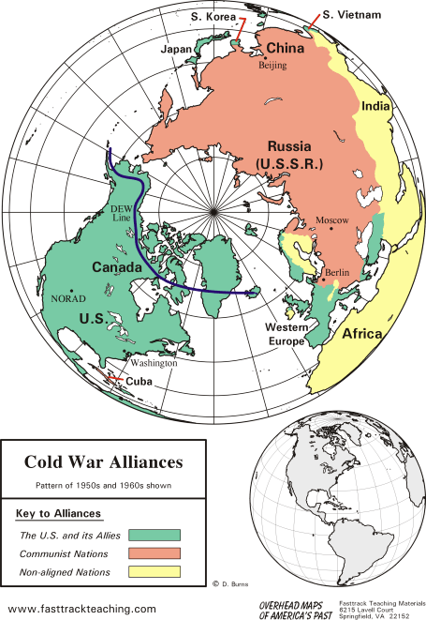**Turning Point: *Gulf of Tonkin Incident***

**A Mini-Assessment**

Name: _____________________

**Short Answers – 22%**

Using the given map (and using specific landmarks), explain what is meant when people said the Cold War world was “polarized.”

Explain what led the United States to begin bombing North Vietnam in August of 1964.

**Mapping Cold War Southeast Asia – 10%**

Label the given items on the map below.

**Map Items**

label North Vietnam, label South Vietnam, label China, label the Gulf of Tonkin,

label the approximate location of the *USS Maddox* on August 4th

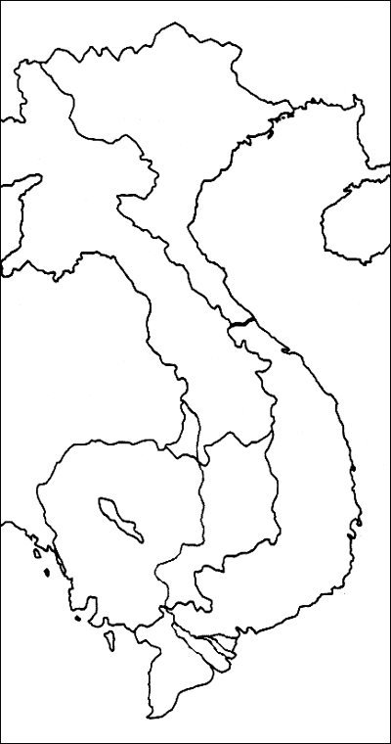

**Summary – 38%**

Read and summarize the following primary source document on a separate sheet of loose-leaf paper. You should identify and explain your top keyword choices (**hint: use more than five**) at the top of your loose-leaf summary.

Joint Resolution  
To promote the maintenance of international peace and security in southeast Asia.

Whereas naval units of the Communist regime in Vietnam, in violation of the principles of the Charter of the United Nations and of international law, have deliberately and repeatedly attacked United Stated naval vessels lawfully present in international waters, and have thereby created a serious threat to international peace; and

Whereas these attackers are part of deliberate and systematic campaign of aggression that the Communist regime in North Vietnam has been waging against its neighbors and the nations joined with them in the collective defense of their freedom; and

Whereas the United States is assisting the peoples of southeast Asia to protest their freedom and has no territorial, military or political ambitions in that area, but desires only that these people should be left in peace to work out their destinies in their own way: Now, therefore be it

Resolved by the Senate and House of Representatives of the United States of America in Congress assembled, That the Congress approves and supports the determination of the President, as Commander in Chief, to take all necessary measures to repel any armed attack against the forces of the United States and to prevent further aggression.

Section 2. The United States regards as vital to its national interest and to world peace the maintenance of international peace and security in southeast Asia. Consonant with the Constitution of the United States and the Charter of the United Nations and in accordance with its obligations under the Southeast Asia Collective Defense Treaty, the United States is, therefore, prepared, as the President determines, to take all necessary steps, including the use of armed force, to assist any member or protocol state of the Southeast Asia Collective Defense Treaty requesting assistance in defense of its freedom.

Section 3. This resolution shall expire when the President shall determine that the peace and security of the area is reasonably assured by international conditions created by action of the United Nations or otherwise, except that it may be terminated earlier by concurrent resolution of the Congress.

-- United States Congress, *Tonkin Gulf Resolution*, August 7th, 1964