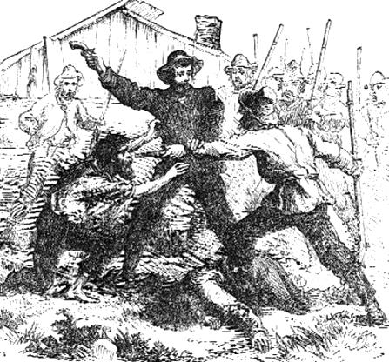**Turning Point: *Bleeding Kansas***

**A Mini-Assessment**

Name: _____________________

**Short Answers – 22%**

Explain what “popular sovereignty” means and explain how it was a compromise on the issue of slavery.

Complete the following Cause and Effect chart by filling in the blank. Under the flow chart, compose a paragraph to explain the cause and effect relationship.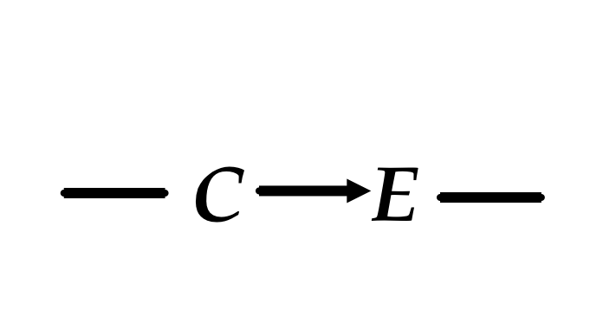

**“Bleeding Kansas”**

**Mapping “Bleeding Kansas” – 20%**

Label the given items on the map below.

**Map Items**

**Circle** the original 13 colonies, put a **box** around the Ohio River Valley, label the Kansas Territory,

label the Nebraska Territory, draw a **DARK** line along the path of the Mississippi River, label the Atlantic Ocean,

label the Pacific Ocean, label the Gulf of Mexico, label Canada, label Mexico

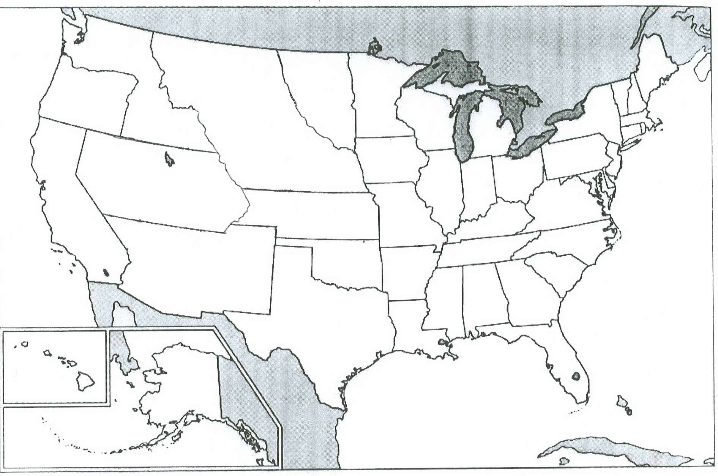

**Summary – 28%**

Read and summarize the following primary source document on a separate sheet of loose-leaf paper. You should identify and explain your top keyword choices here on this page.

KEYWORDS & WHY

The crime is committed. The work of Monroe, and Madison, and Jefferson, is undone. The wall they erected to guard the domain of Liberty, is flung down by the hands of an American Congress, and Slavery crawls, like a slimy reptile over the ruins, to defile a second eden.

They tell us that the North will not submit. We hope it will not. But we have seen this same North crouch lower and lower each year under the whip of the slave driver, until it is hard to tell what it will not submit to now. Who, seven years ago, would not have derided a prophecy that Congress could enact the kidnapping of free citizens, without judge or jury? Who would have believed that it could enact that white men have a right to hold black in slavery wherever it is their sovereign will and pleasure? And yet, who now will deny that that prophecy is more than realized?

It was fitting that the Law should be passed as it was. It was in accordance with its spirit that it should be conceived in treachery, sprung upon the House by a fraud, and forced through it by a Parliamentary lie. It was appropriate that one member should be bribed and another bullied, and another bought, until the ranks of Slavery were full. Had Law or Order or Honesty had aught to do with its passage, there would have been a strange incongruity between the means and the end.

We cannot read the future. We cannot predict what will be the consequences of this last and most fatal blow to Liberty. But we can see what the duty of Freemen is, and we mean it shall be through no fault of ours if it is left undone.

-- Anonymous, *New York Evening Journal*, May 23rd, 1854