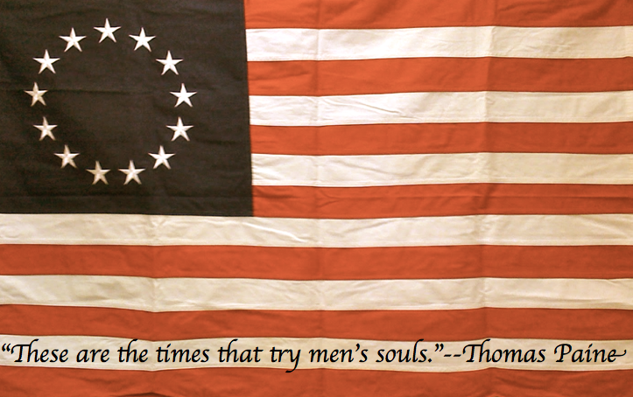
The War for American Independence

Name: _________________________
7th Grade History
Mr. Robertson

Short Answer – 40%

Answer the following prompts on a separate sheet of loose-leaf. Remember, short answer responses should be eight to twelve sentences in length and have three clear pieces of evidence to prove your thesis. No evidence (battle or strength or weakness) may be used more than once in this section. You may use the space below each prompt to brainstorm your evidence.

1. Did Great Britain lose or the Americans win the Revolutionary War?
- Identify and explain one battle that will support your chosen position.

2. Identify and explain two strengths of the Continental Army and one weakness of the British to support
the following thesis statement.

Despite being outmatched, the Continental Army had many advantages at the outset of the Revolutionary War.

DBQ: Reasoning for Independence – 24%
Below is an excerpt from the Declaration of Independence. You will annotate this document and summarize the Americans’ four-step argument for independence by following the prompts below. On a separate sheet of loose-leaf you will use the selected excerpts to summarize the argument in your own words (not the usual summary format – simply take the four passages you highlighted and state them in your own words).
We hold these truths to be self-evident, that all men are created equal, that they are endowed by their Creator with certain unalienable Rights, that among these are Life, Liberty and the pursuit of Happiness.--That to secure these rights, Governments are instituted among Men, deriving their just powers from the consent of the governed, --That whenever any Form of Government becomes destructive of these ends, it is the Right of the People to alter or to abolish it, and to institute new Government, laying its foundation on such principles and organizing its powers in such form, as to them shall seem most likely to effect their Safety and Happiness.

1. Circle the passage that refers to the colonists’ basic belief of humankind.

2. Underline the passage that refers to what rights we retain and how we receive them.

Box in the passage that refers to the purpose of government.

3.

4. Draw a line over the passage that refers to the explanation for why the colonies must split from England.

Summary:

ON A SEPARATE SHEET OF PAPER
DBQ: Supporting the Claim to Independence – 26%
Below is an excerpt from the Declaration of Independence. You will annotate under six of the following passages by writing the historical event that the author is referring to (no repeats, each of the six annotations must be a unique event). In the space to the right of the passage, choose three of the events that you annotated and explain in two to three sentences how it could be used as evidence to prove the argument you summarized on the previous page.
He has dissolved Representative Houses repeatedly, for opposing with manly firmness his invasions on the rights of the people

For Quartering large bodies of armed troops among us:

For cutting off our Trade with all parts of the world:

For imposing Taxes on us without our Consent:

For depriving us in many cases, of the benefits of Trial by Jury:

He has erected a multitude of New Offices, and sent hither swarms of Officers to harrass our people, and eat out their substance.

He has excited domestic insurrections amongst us

For depriving us in many cases, of the benefits of Trial by Jury:

1.

2.

3.

Sequencing Historical Events – 10%

Place the events below in the correct sequential order by placing the corresponding numbers in the spaces provided.

1. Battle of Long Island
2. Treaty of Paris
3. Battle of Yorktown
4. Battle of Trenton
5. Battle of Saratoga

______ ______ ______ ______ ______

1. Declaration of Independence
2. Battle of Lexington and Concord
3. Olive Branch Petition
4. Battle of Long Island
5. Battle of Bunker Hill

______ ______ ______ ______ ______

